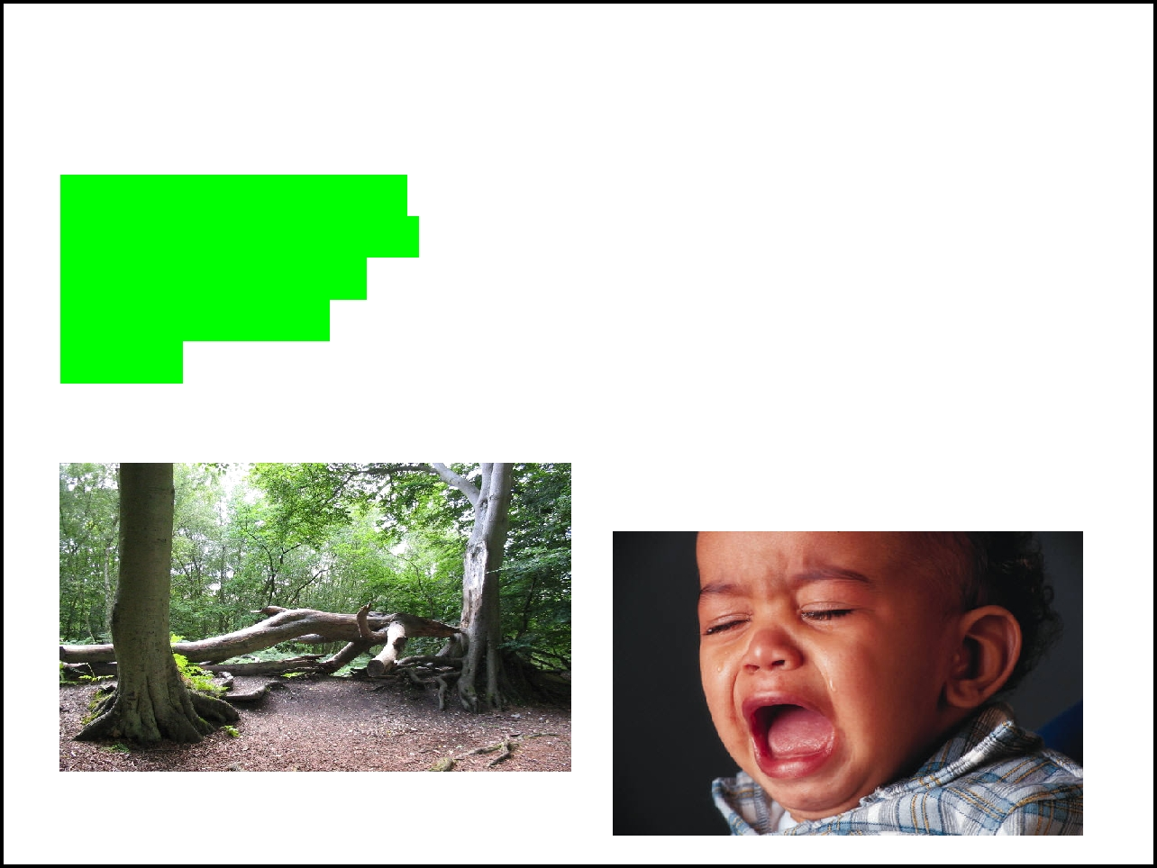
Sound Waves

Sound Waves are produced when vibrations from an object (like a
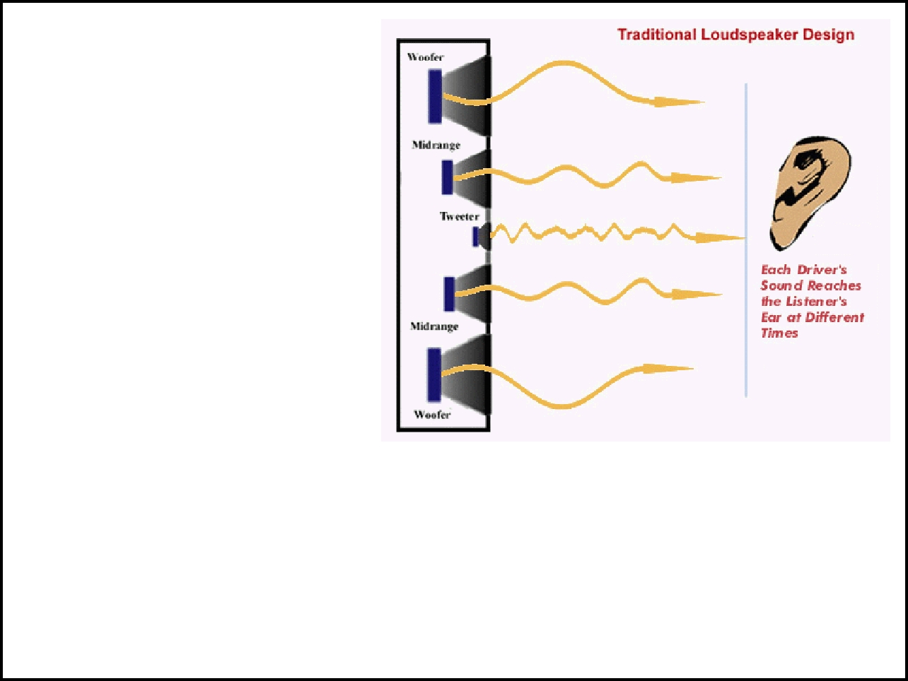

If a tree falls in the forest and no one is around to hear it does it make a sound?

What causes sound?

speaker) ___________ ______________in the air and pass energy to them.

Sound waves are compressional waves

Sound waves can travel through other mediums, like _______________.

They cannot travel through __________.

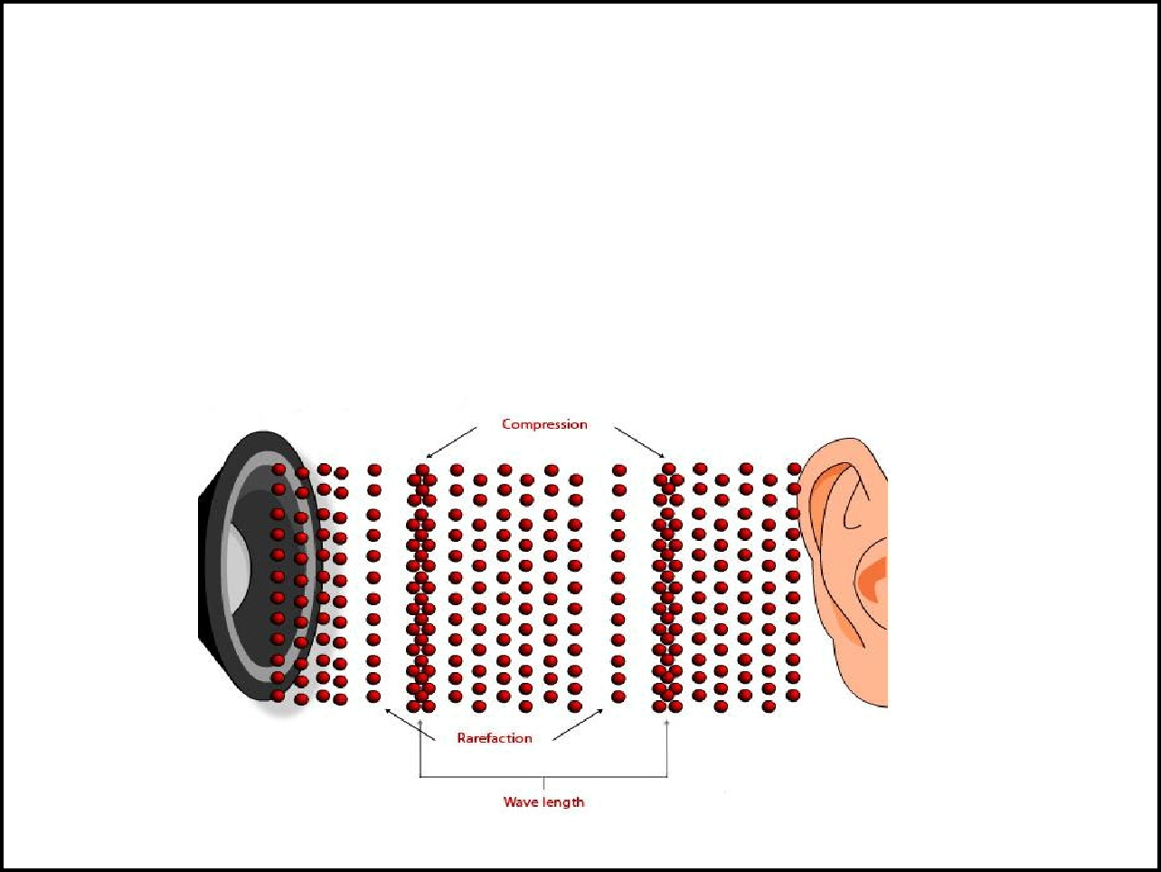

Speed of Sound

Depends on

- __________________ (gas, liquid, types of solids)

- ____________________ - sound travels faster through warm air

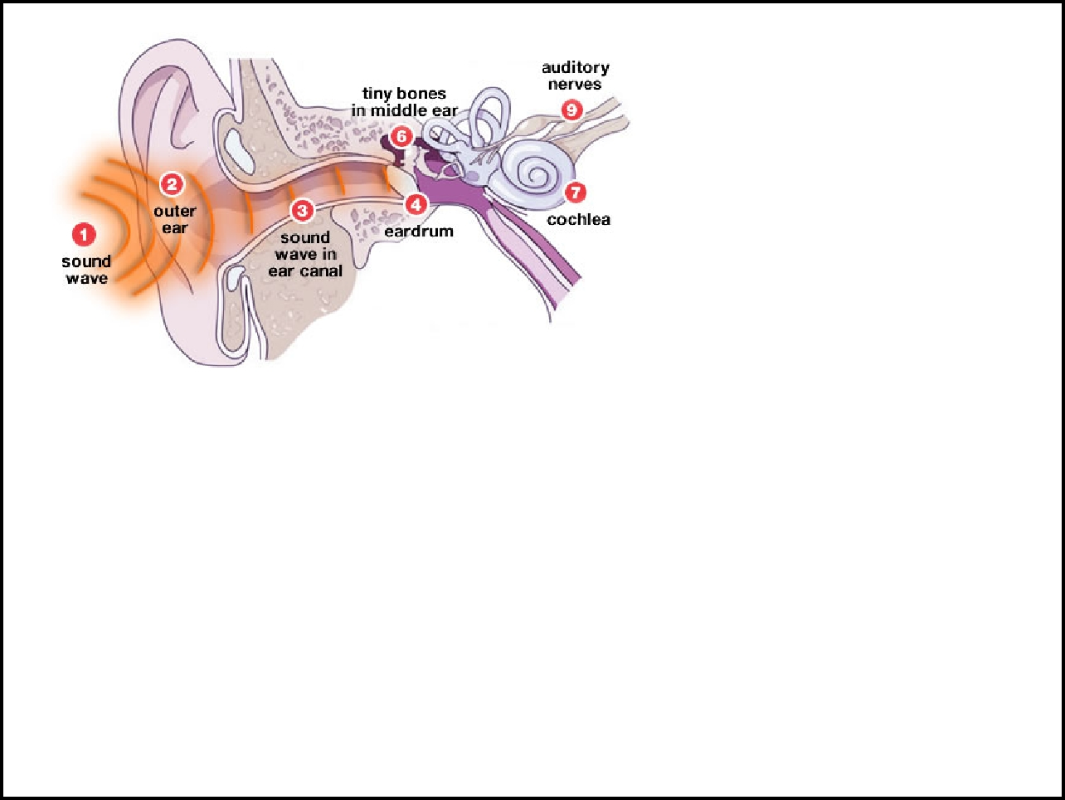

Is hearing and listening the same thing?

How we hear sounds:

- ___________________________ waves enter ear

- Eardrum transfers waves to 3 tiny bones - all serve to ______________
- Waves are converted to nerve impulses by the _____________

- Brain decodes and __________________that information

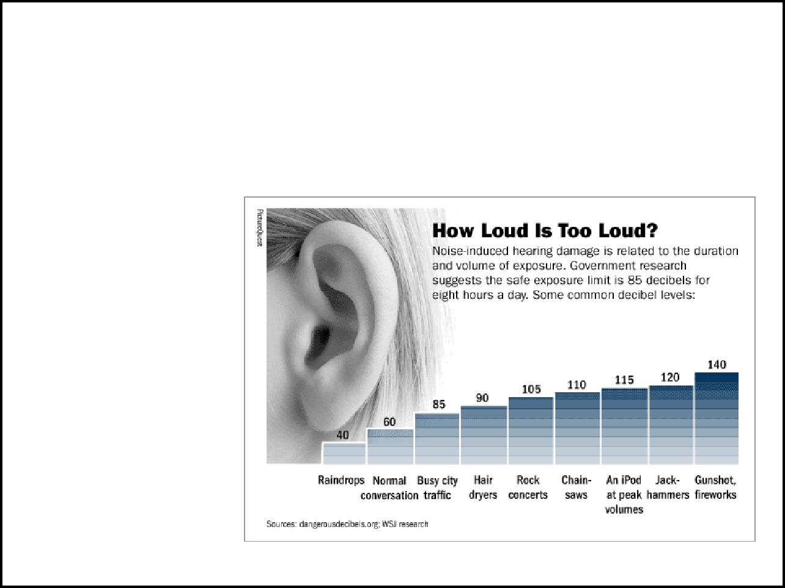
Intensity = amount of energy that flows through a certain area, we _____________________________________

Intensity ________________________ with distance

__________ (dB) - measures

sound intensity

Sounds over _____dB may cause pain and hearing damage
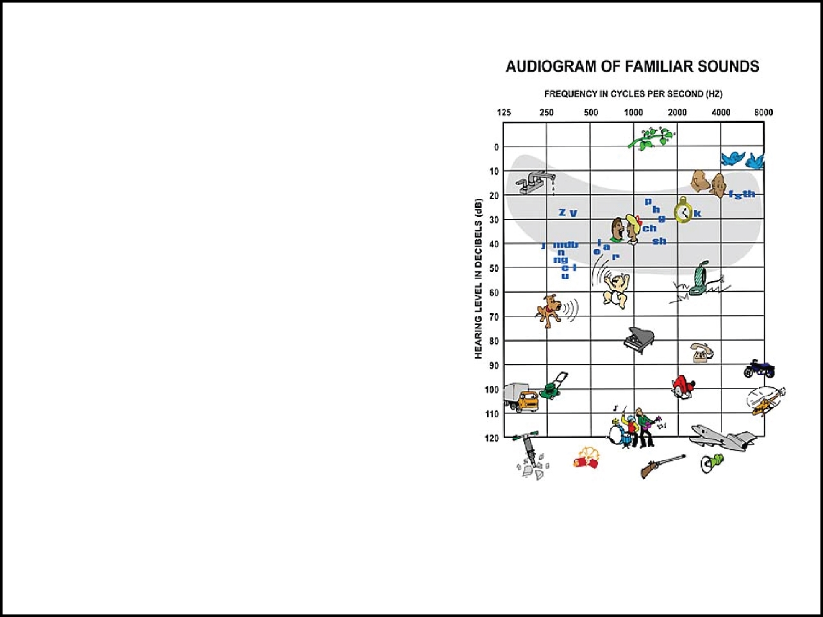
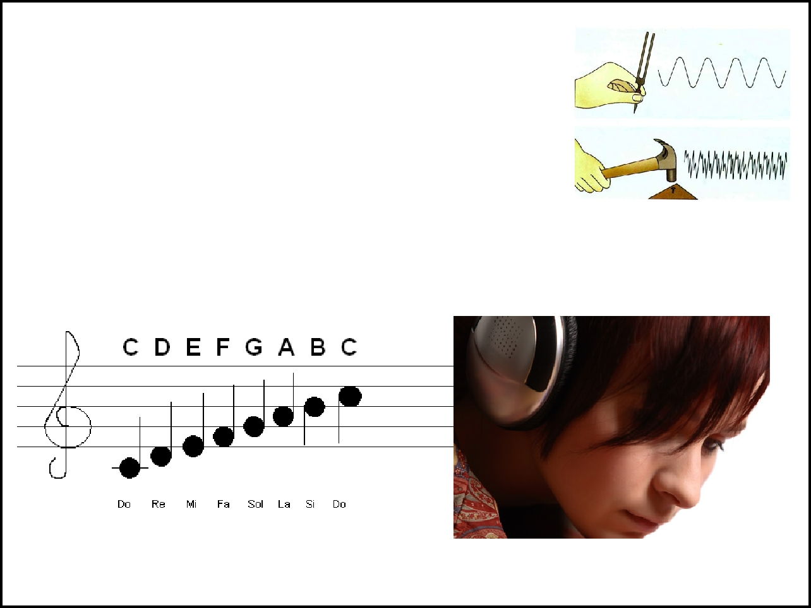
Pitch is related to _________ of sound waves

do, re , mi, fa, so, la, ti, do

http://www.flashmusicgames.com/

A healthy human ear can hear at frequencies from ___________ Hz

As you grow older, many of the _____________ in your ears become damaged, which results in hearing loss.

The mosquito ring tone capitalizes on this by providing teenagers a ring that _________________

Test it at http://www.jimmyr.com/blog/hearingloss.html

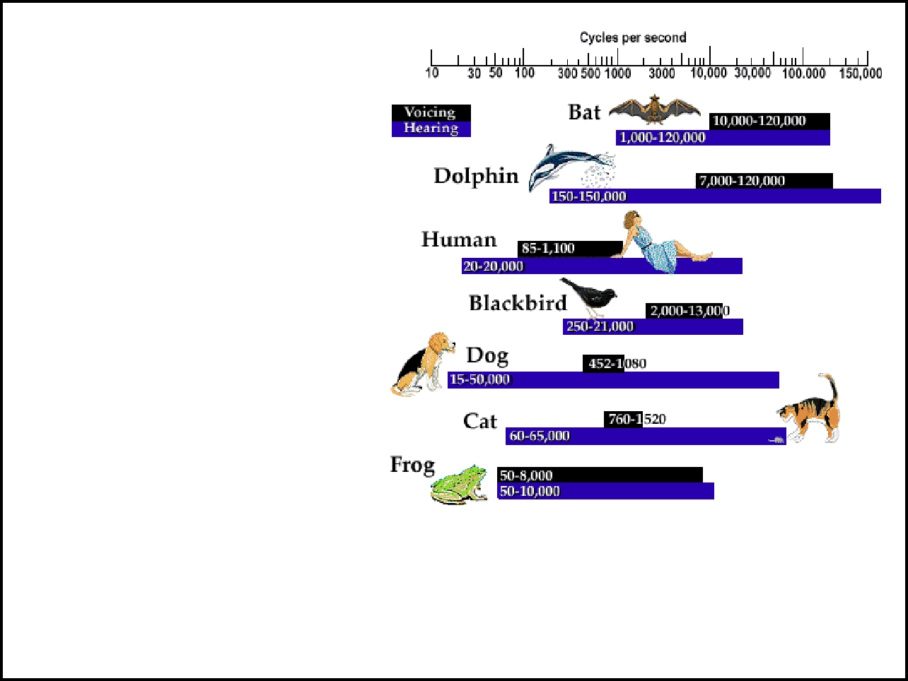
Most people can't hear sound above 20,000 Hz - these are called ____________ waves

Dogs can hear up to _____________

__________ waves have frequencies below 20 Hz

You might not hear them, but you can feel them "rumble"

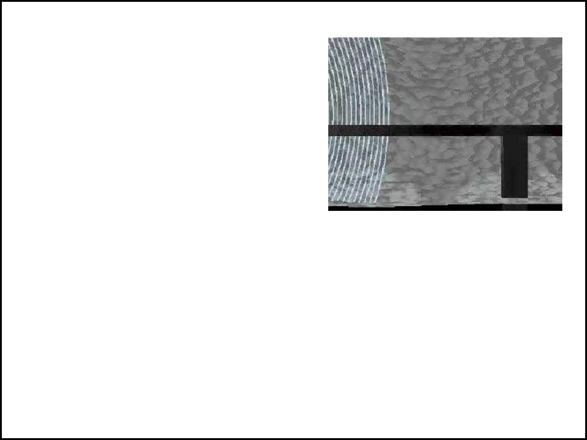
The Doppler Effect

Moving objects that have sound change pitch depending on their direction and speed - this is called the _______________

Imagine the sound of a siren as it gets closer to you and then moves away.

Animation of Doppler Effect
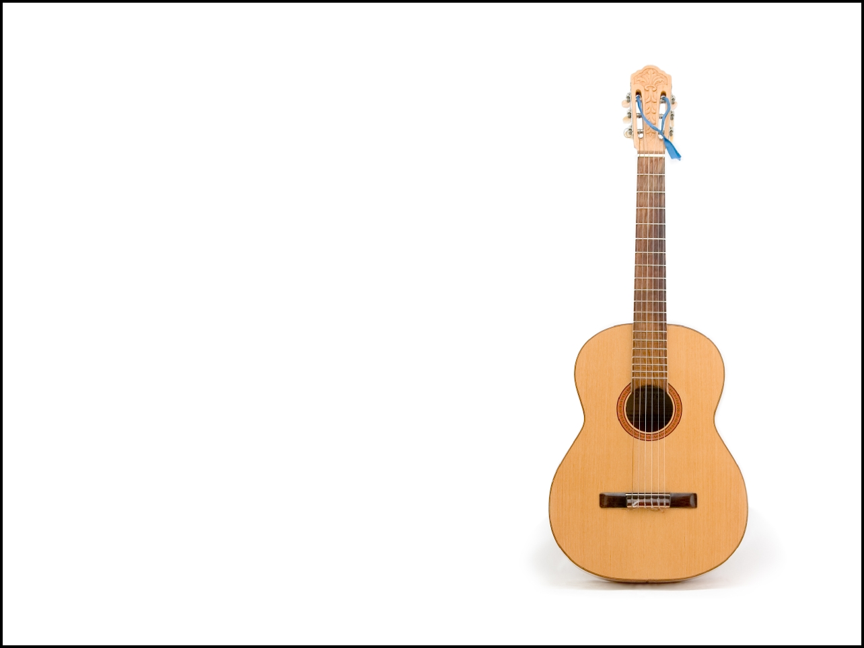

Types of Instruments

1. Strings

__________________________

Strings produce notes, hollow chamber (resonater) amplifies sound

Stretching the strings changes the pitch - something you can try with a __________________
Music
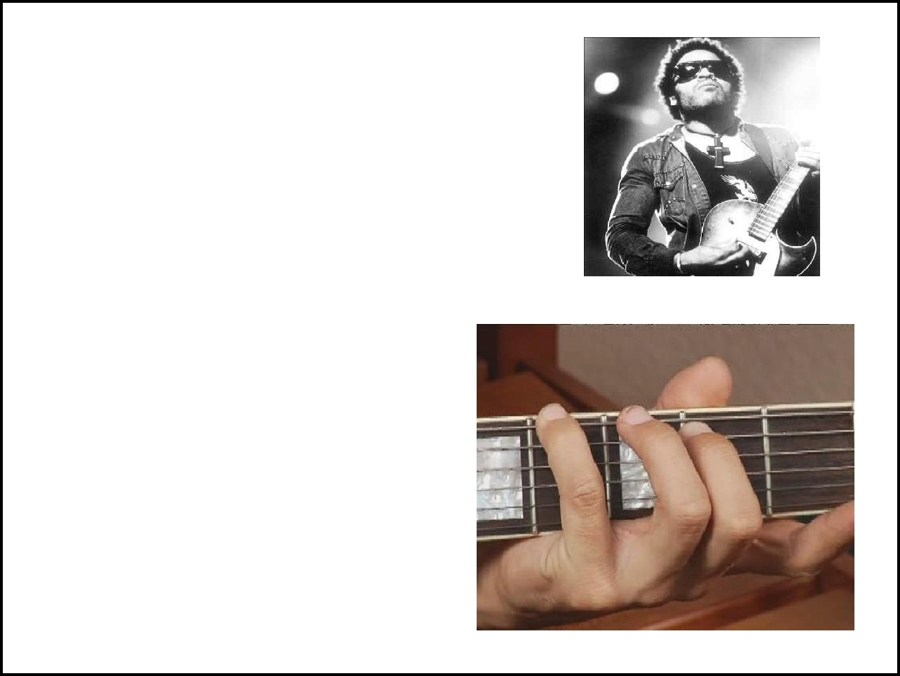
Sounds used in a ____________________

Instruments produce sounds of different frequencies

Frequencies of guitar strings depend on thickness, length and how tightly it's ________

Sound is amplified by ______________, instruments have a component that make the sound louder
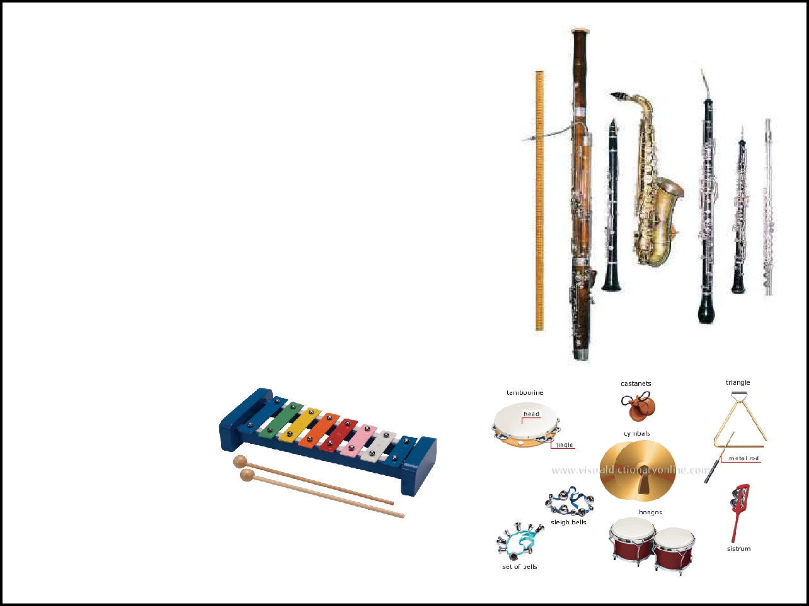

- Brass and Woodwinds ____________________ Examples: flute, trumpets

- Percussion

_____________ to produce air vibrations

Examples:

drums, xylophones
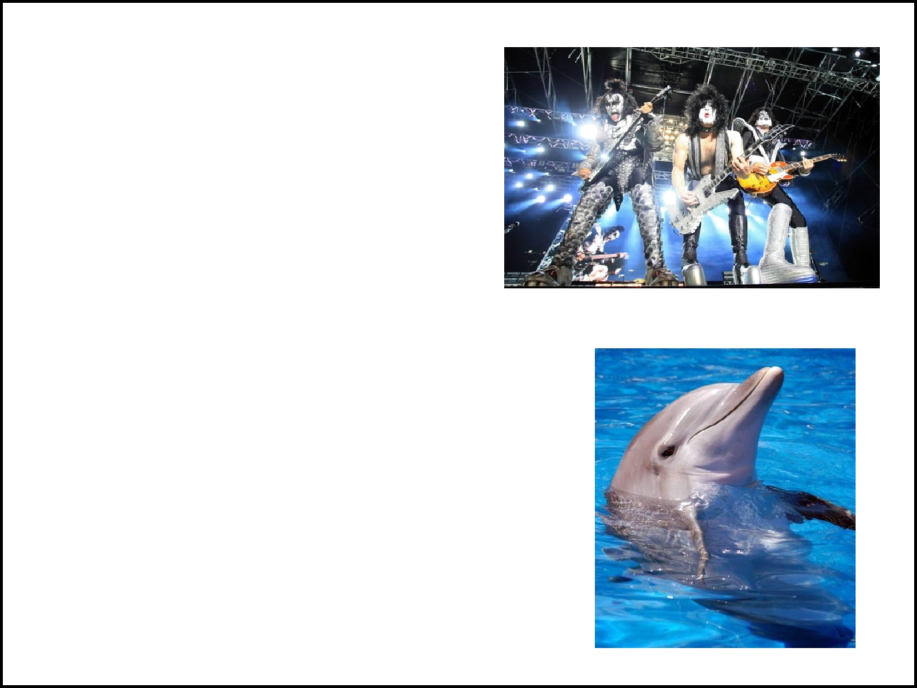
Acoustics = _________
__________________

The design of concert halls can change the way music sounds due to reflection and absorption of sound waves

Echolocation

Some animals can use sound to identify and track prey.

________________ use echolocation
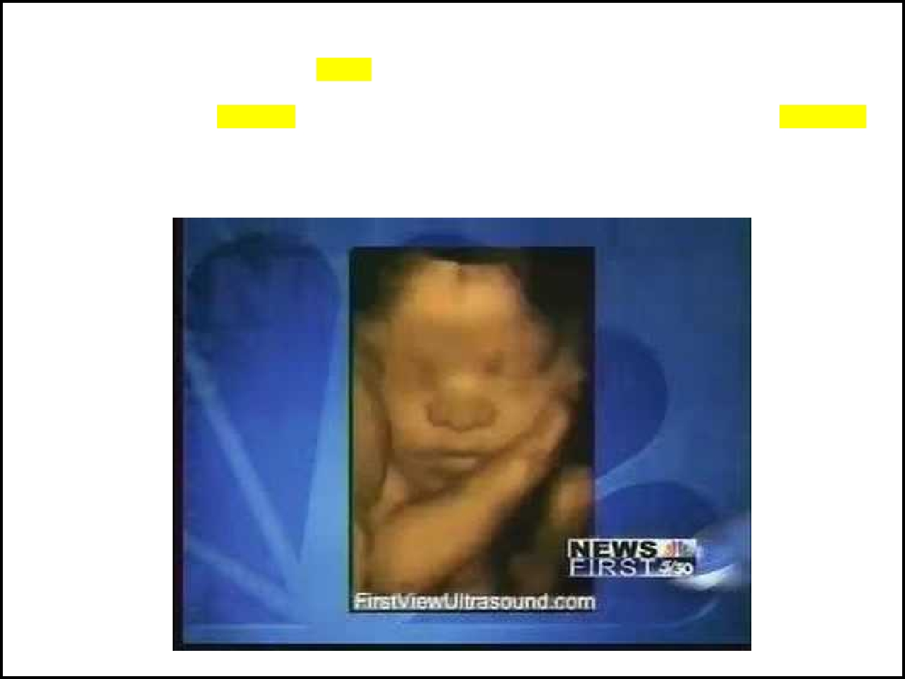

As the technology of ultrasounds grows, we've seen a new wave of ultrasound from the traditional two dimensional (2D) ultrasounds to the three dimensional or 3D ultrasounds. While many women seem to prefer the look of the new ultrasound as more realistic, they are still not available in every location. Generally, you can certainly find a 3D ultrasound available for most high risk pregnancy centers. More and more physicians and midwives are getting this machines available in their offices. You are most likely to see this offered at the mid-pregnancy ultrasound around the 18-20th weeks of pregnancy.

Ultrasound Imaging
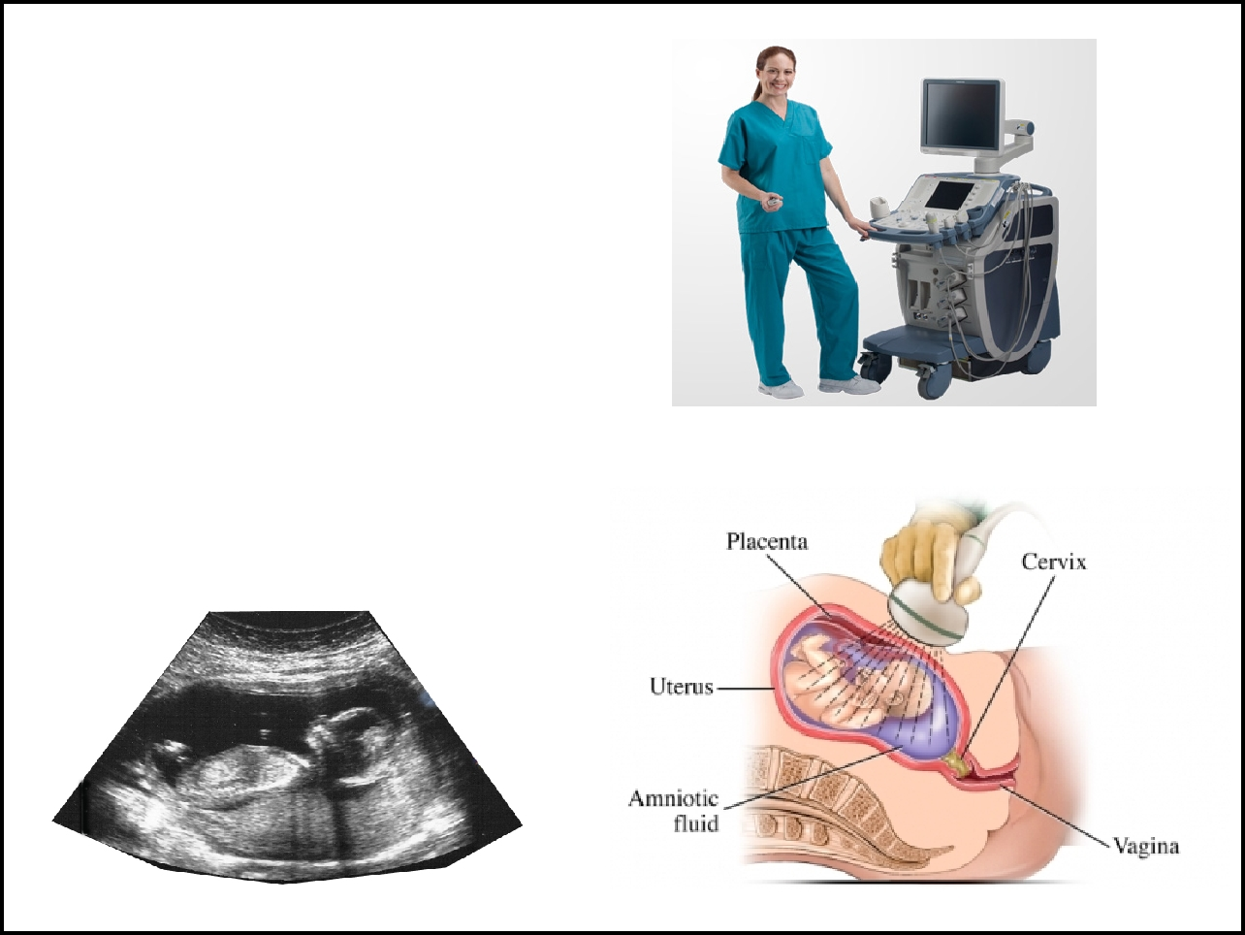
Ultrasound waves are directed at a body, the waves reflect off organs and produce signals that are sent to a __________. The monitor produces an image of the organ

The image produced is called a _____________________
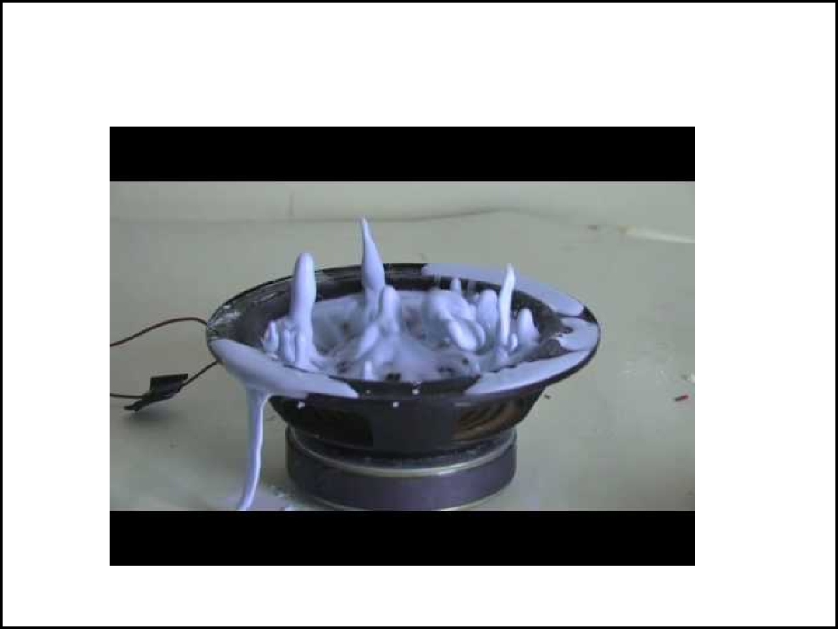

Using cornstarch and the right frequency of sound - you can make a...... CORN STARCH MONSTER

