More inexact numbers...
1. How much liquid is
in this graduated cylinder?

2. What is the temperature?

3. How much does she weight?

There are two types of numbers..
EXACT NUMBERS

Example: There are exactly 12 eggs in a ________________

INEXACT NUMBERS

Any measurement
where you must _______
at a value

How big is this beetle?

Math and Physics



Scientific Notation
Using a Calculator

What do we do when numbers are too big to write or put in a calculator?
How many cells are in the human body?

5000000000000000
50 million million
________________________________

5.0 x 10 ¹⁴

^ ______________________________ ^

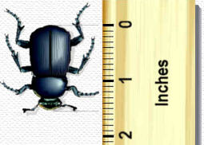

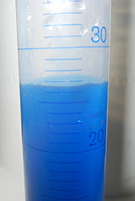

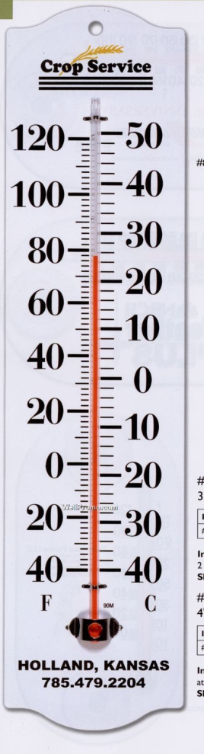


How much is a trillion?

So how much is a thousand billions,
or a million millions?
If you opened a business on
January 1st in the year One
and lost a million dollars a day,
every day since, 7 days a week,
365 days a year, you wouldn't
lose a trillion dollars until the year ___________.

Also……somewhere between you 31st and 32nd birthday, you celebrate your __________________ second of being born. You would have to live until you were __________________ years old to celebrate your 1 trillionth second.

Scientific Notation
Some numbers in science are just too big or ________________ to easily deal with.

The __________________________ (the closest one to our Milky Way galaxy) contains at least 200,000,000,000 stars.

That’s _______________ billion!

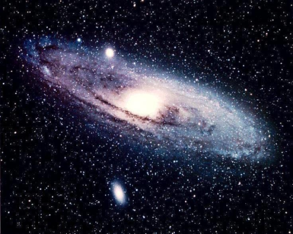

Back to scientific notation....
Remember the number of stars in the Andromeda galaxy... we could write 200,000,000,000 in scientific notation as:
2.0 x 10¹¹
The exponent refers to the number of zeros that follow the 1. So:
10¹ = 10 =
10² = 100 =
10³ = 1,000 =
10⁴ = 10,000 =

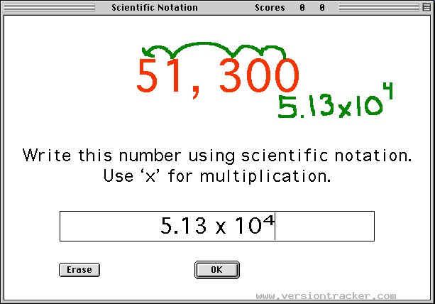

Convert this to scientific notation:

232,500


Negative notations indicate numbers smaller than 1

10⁻¹ = 1/10 = .1
10⁻² = 1/100 = .01
10⁻³ = 1/1,000 = ________

So, in practice

4.0 x 10² = ________(2 places to the right of 4)
4.0 x 10⁻² = ________ (2 places to the left of 4)

Now for something really interesting...
Rules for Multiplication in Scientific Notation:
1) Multiply the coefficients
2) Add the exponents (base 10 remains)
Example 1: (3 x 10⁴)(2x 10⁵) =
What happens if the coefficient is more than 10 when using scientific notation?
Example 2: (5 x 10 ³) (6x 10³) =
While the value is correct it is not correctly written in scientific notation
Convert 30.x10⁶ to 3.0 x 10⁷ in scientific notation.

Practice Multiplying these

1. 4.0 x 10³ ( 2.0 x 10² )

2. 3.0 x 10⁸ ( 3.0 x 10⁷ )

3. 5.0 x 10⁴ ( 2.0 x 10³ )

4. 9.0 x 10⁵ ( 3.0 x 10⁴ )

If that is all really confusing, no worries - just use a calculator.

Find the sci. notation button on the calculators.....

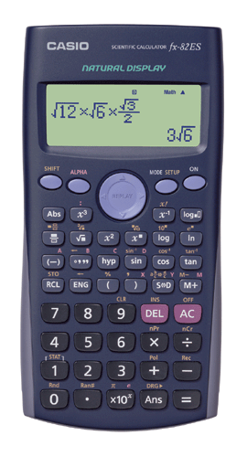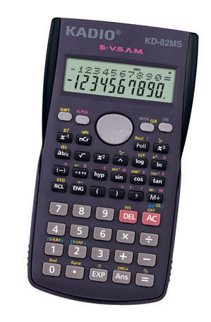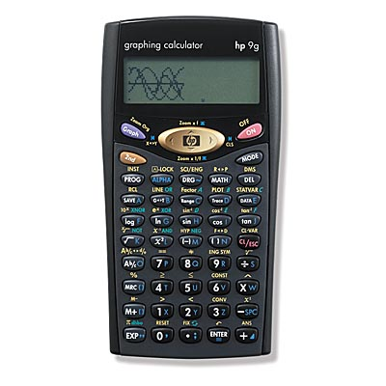


Calculator Tips and Tricks
Calculators follow and order of operations.
If you input numbers in the wrong order,
the calculator will give you the wrong answer.

First, do this problem in your head, then try it on the calculator.

1 + 2 x 5 =

In a calculator, multiplication is handled first

(1+2) x 5 =
1 + (2 x 5 ) =

Those are different numbers. It matters which you do first and how you punch them into the calculator. Math has rules!

Practice Exponents on Your Calculator

1. 4.0 x 10³ ( 4.0 x 10² )

2. 3.0 x 10⁵ ( 1.0 x 10² )

3. 7.0 x 10¹³ ( 2.0 x 10⁸ )

4. 4.5 x 10³ ( 7.1 x 10¹¹ )




PLEASE EXCUSE MY DEAR AUNT SALLY!

Rules of Operations - PEMDAS!
P: Parentheses first

6 × (5 + 3)= 6 × 8= 48
E: Exponents (ie Powers and Square Roots, etc.)
5 × 2²= 5 × 4=20

MD: Multiplication and Division (left-to-right)

2 + 5 × 3 =2 + 15 = 17
30 ÷ 5 × 3 =6 × 3= 18 (left to right)
AS: Addition and Subtraction (left-to-right) - go last

More inexact numbers...

1. How much liquid
is in this graduated cylinder?

2. What is the temperature?

3. How much
does she weight?

What do we do when numbers are too big to write or put in a calculator?
How many cells are in the human body?

5000000000000000
50 million million
________________ cells

5.0 x 10 ¹⁴

^ ________________________ ^

There are two types of numbers..
EXACT NUMBERS

Example: There are exactly 12 eggs in a ________________

INEXACT NUMBERS

Any measurement
where you must _______
at a value

How big is this beetle?

Math and Physics

Scientific Notation
Using a Calculator

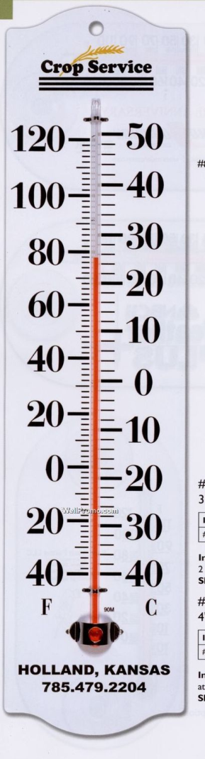

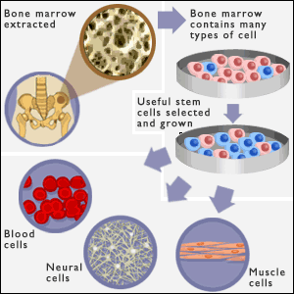
What do we do when numbers are too big to write or put in a calculator?
How many cells are in the human body?

5000000000000000
50 million million
________________________________

5.0 x 10 ¹⁴

^ ______________________________ ^

More inexact numbers...
1. How much liquid is
in this graduated cylinder?

2. What is the temperature?

3. How much does she weight?

