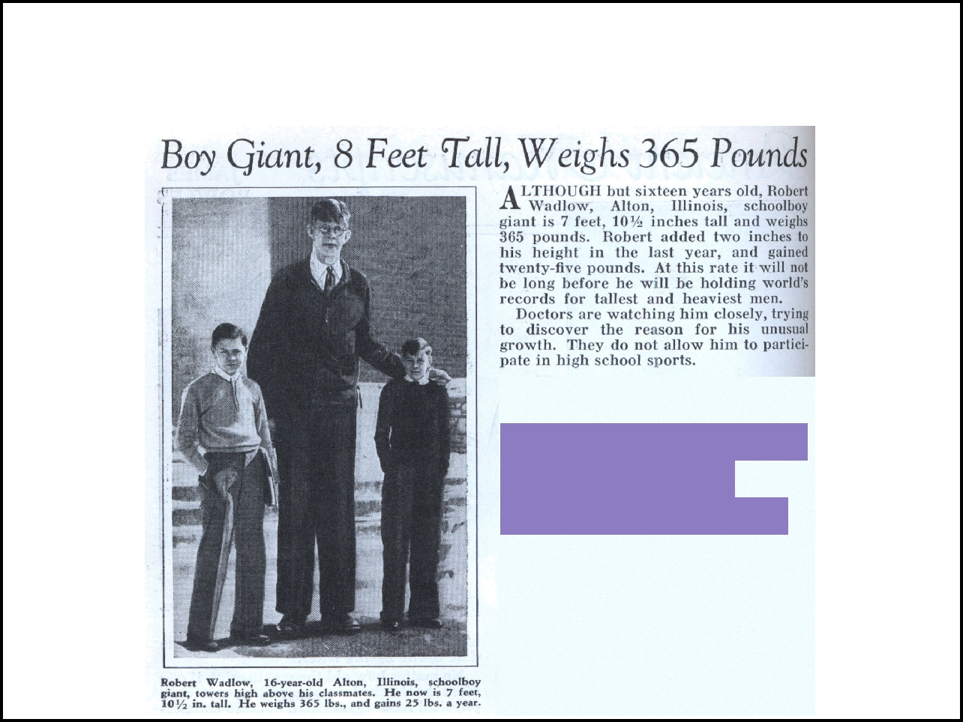
Standards of Measurement

Newspaper clipping - can you find the measurements in it?
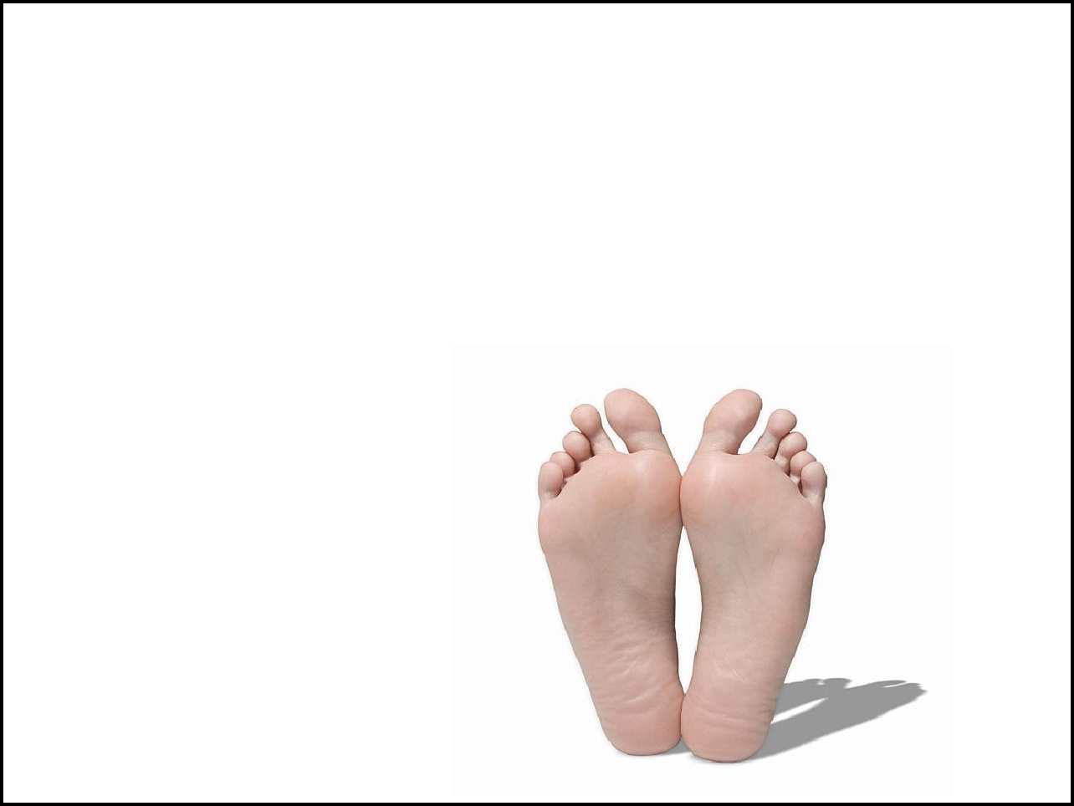

Historically, body parts were used as measuring devices

The height of a horse was measured in _______

Foot comes from the average length of a person's __________

A _________ is the length of
___________________

*What is the main problem with this kind of system?

A standard is an ___________that people agree to use to compare _______________________.
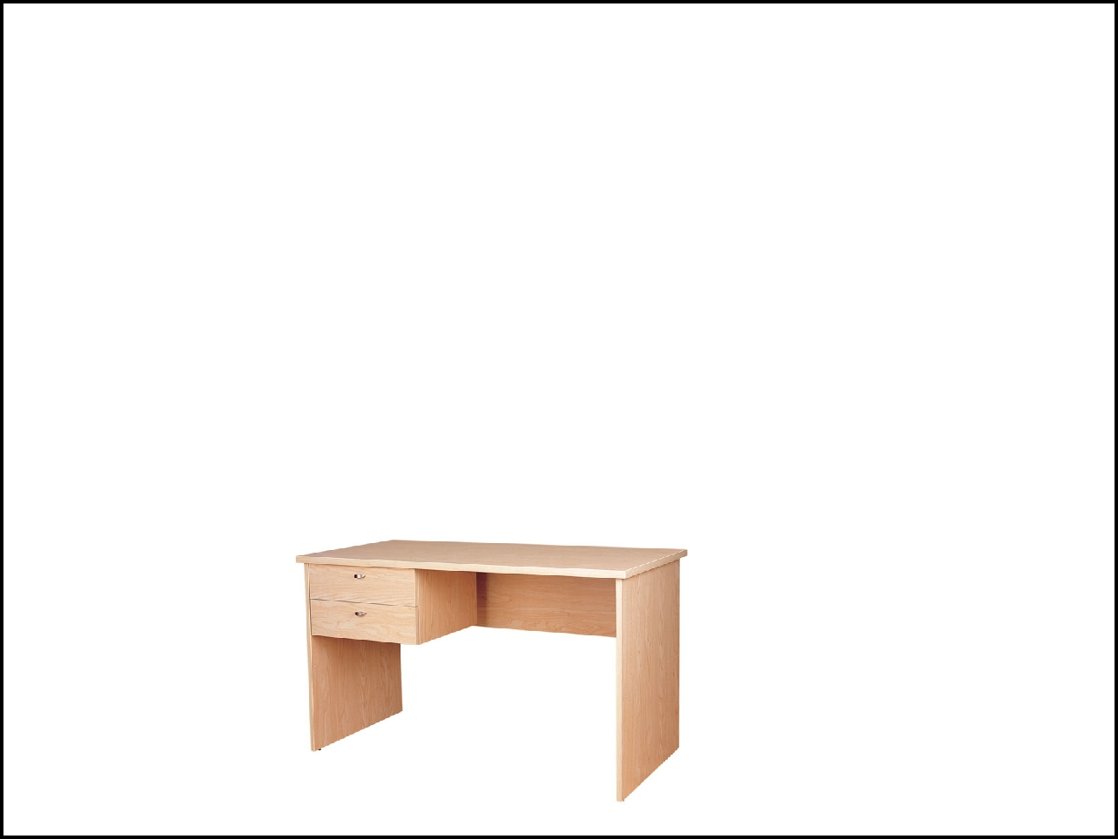
Scenario: You and your friend need to move a desk but you're not sure if it will fit in your trunk. You don't have a ruler or other tool on you. How can you quickly determine if the desk will fit?
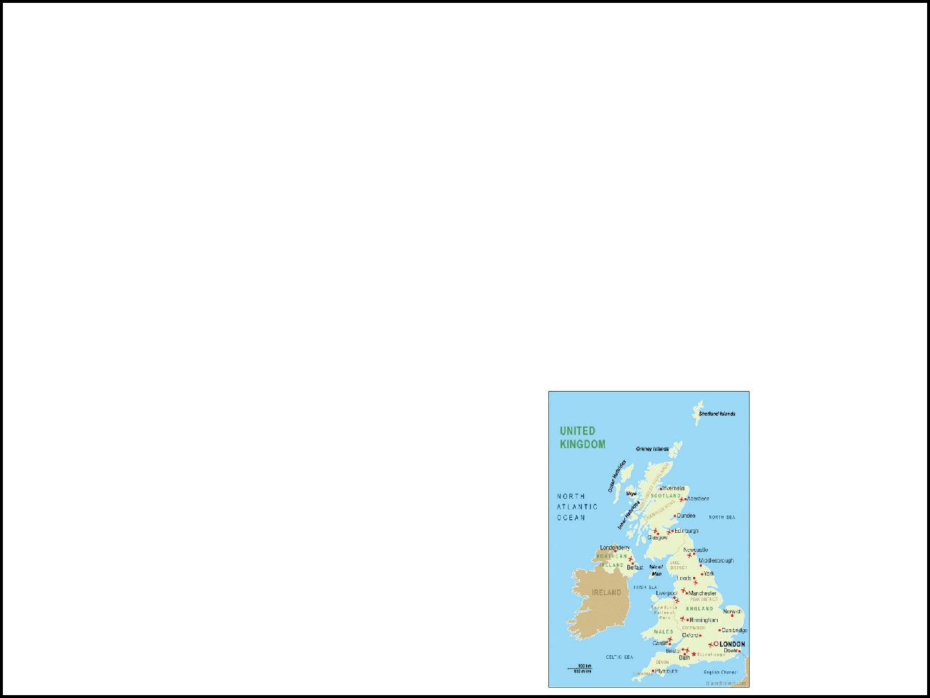

Match the unit with the item...
A _______________ of milk. | a. pound
A __________ of material. | a. pound
A __________ of material. | b. miles
A __________ of potatoes. | b. miles
A __________ of potatoes. | c. foot
A __________ of rope. | c. foot
A __________ of rope. | d. yard
You are driving 60 _______ per hour. | d. yard
You are driving 60 _______ per hour. | e. gallon

The units above use an ENGLISH system of measurement - used mainly _____________________.

Most other countries use the
______________________________

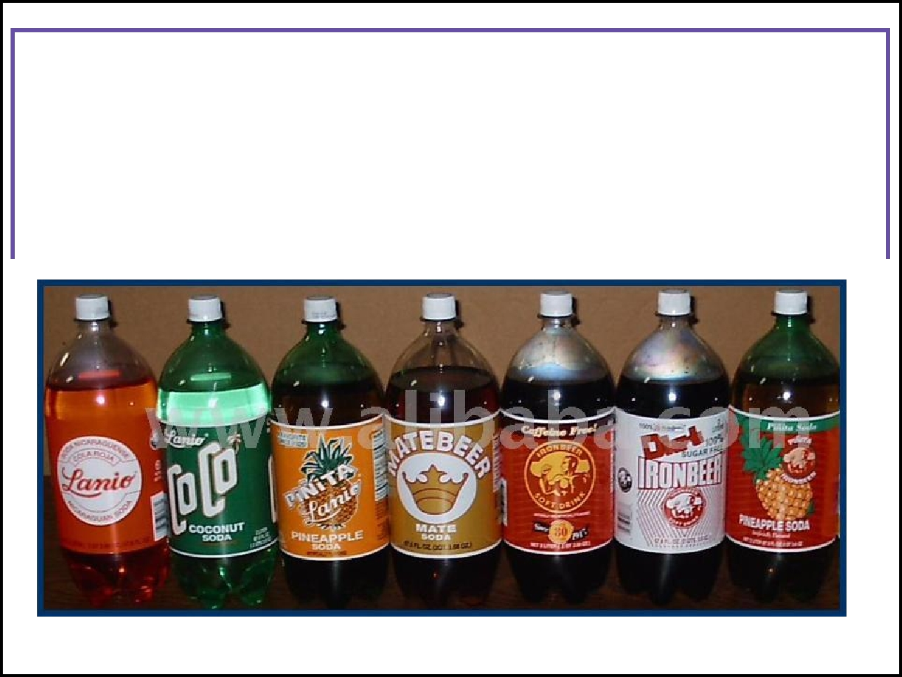
You are probably also familiar with some of the metric system

units. Match these...

A 2 ______ bottle of soda. |  | a. gram
A ________ of sugar.
 |  | b. | liter
A | ________ stick. | b. | liter
A | ________ stick. | c. meter

_________________ - all countries agreed upon system used by all scientists.

Abbreviated to: ____ standards (units)

_____________ = meter (m), centimeter (cm), or millimeter (mm)

___________ = kilogram (kg) or gram (g)

_____________ = liter (l) or milliliter (ml)
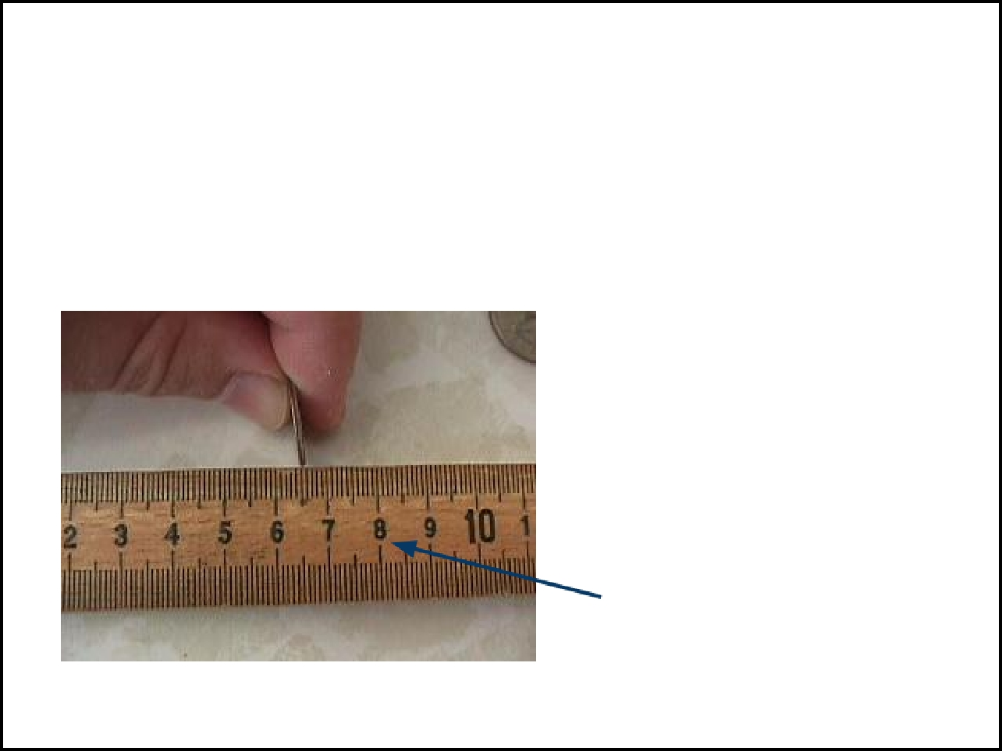

Be warned.

You will be doing math in this class.

If a doctor orders 10 cc's of insulin, how many mls is that?

Metric system units are _____________, so it is easy to convert

Ex. There are _____________
_____________
A mm is about as thick as a dime. Notice there are about 10 dimes between the 6 and the 7 on this photo.

The large numbers represent centimeters.


Don't worry about converting inches to centimeters - just measure in centimeters to start with.

Use your ruler to calculate ..

- Width of your desk _______ cm

- Width of your desk ______ mm

- Length of your index finger _____ cm

- Length of your index finger ______mm
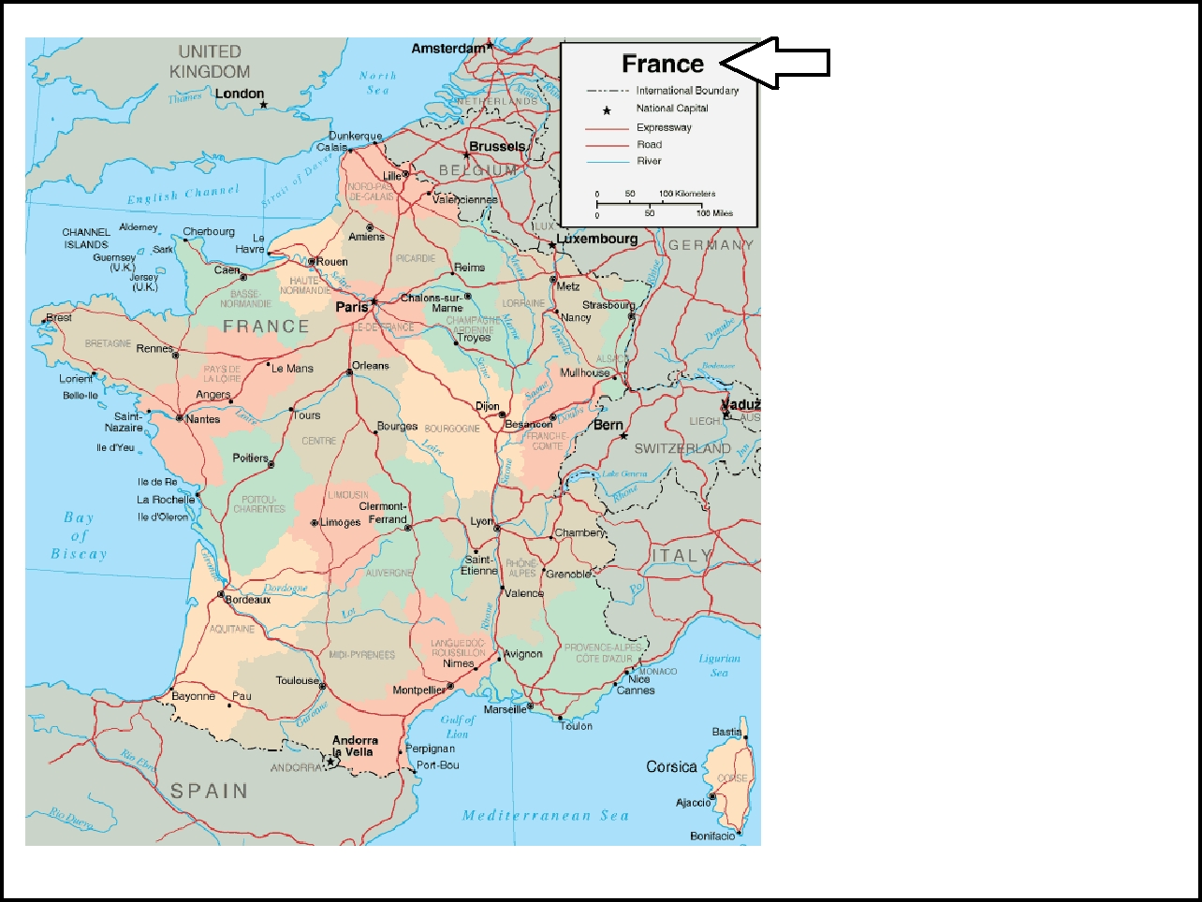

Use the scale to determine the distance between Paris and Brussels.

In Kilometers?

In Miles?

1 kilometer = 0.62 mi
Length Measurements
_____________ = small objects, like a quarter _____________= small objects, your foot or even your height
_____________ = larger distances, the size of a room
_____________ = much larger distances, St. Louis to Springfield

What are the english units for the lengths above?
__________________________
__________________________

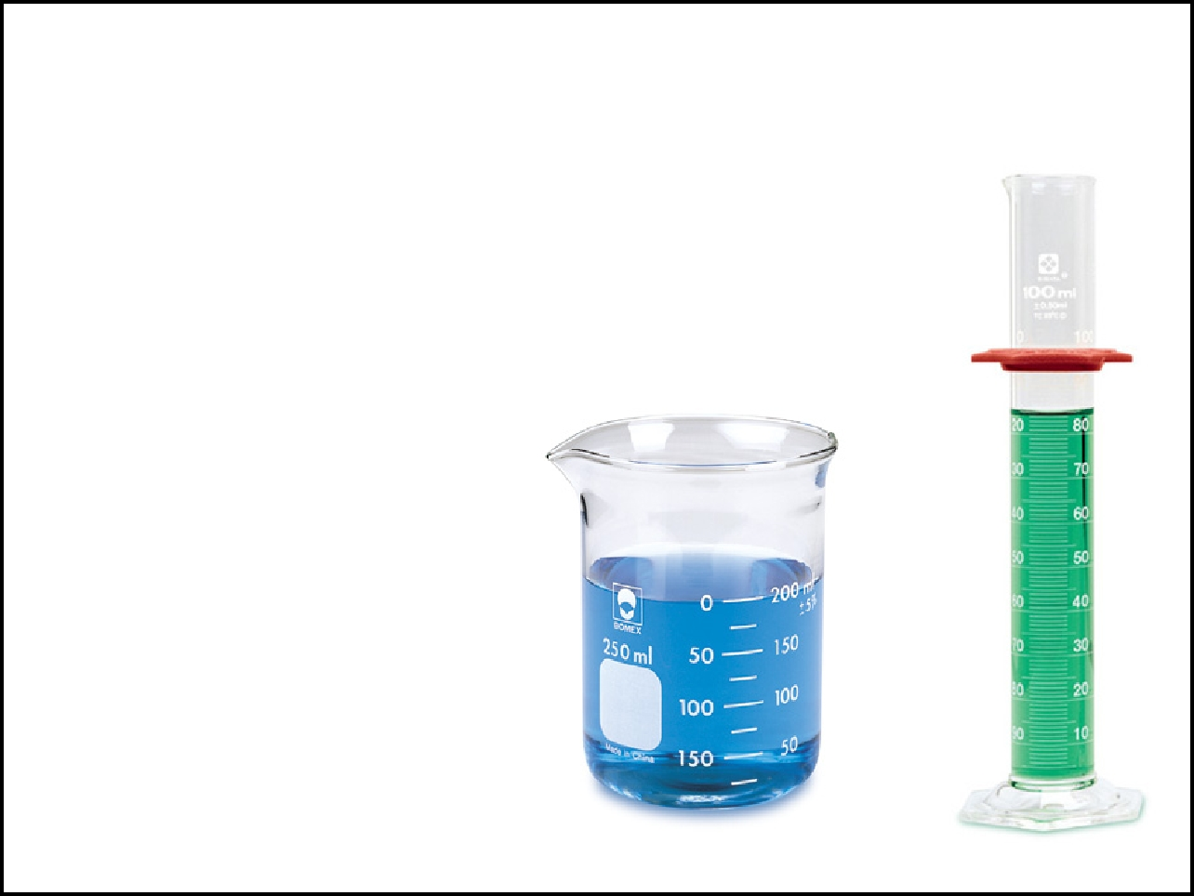

_____________measures the amount of something, usually a liquid.

SI units for volume
_____________
_____________

___
Beakers and Graduated cylinders used to measur
 |  | _____________: the amount of matter in an
CC = cubic |  | object
centimeter, which |  | Measured in _____________ and _____________
is the same as a |  | Measured in _____________ and _____________
ml |  | Measured in _____________ and _____________
Used in _____________ |  | Weight measures mass + gravity
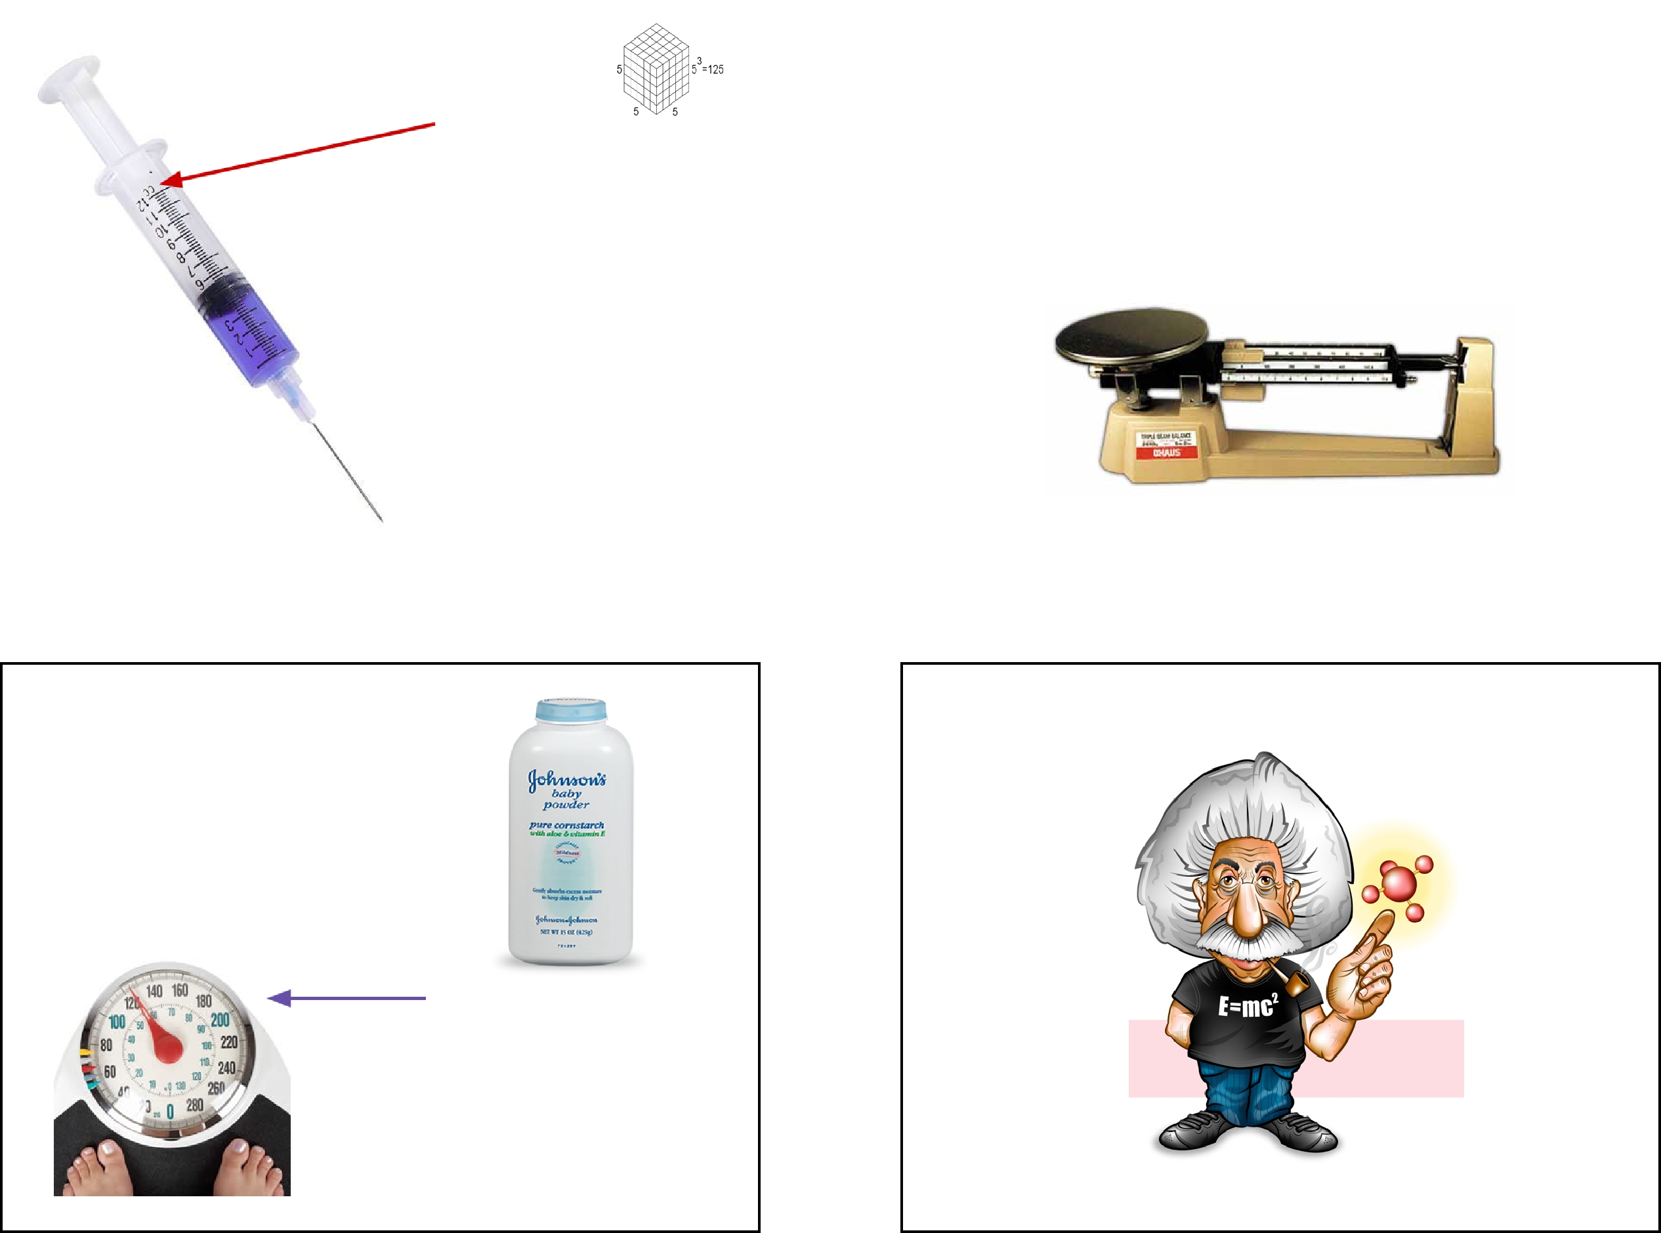

Units of Weight | Quiz Time

Grams for small objects or foods

Kilograms for larger objects like people
______________________________

Some scales show both pounds and kilograms. How much does this person weigh?

