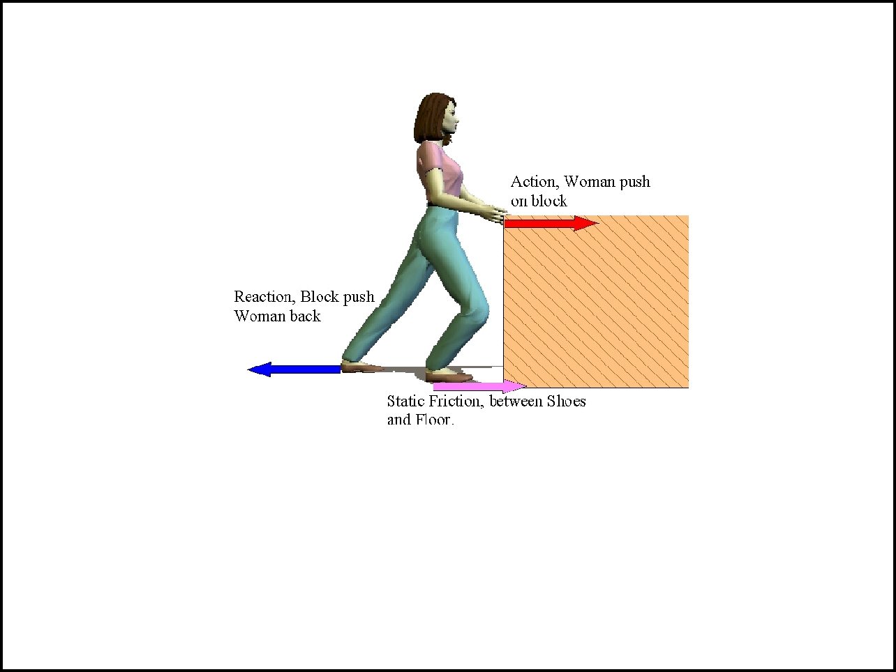

Forces

Gravity and Newton's 2nd Law
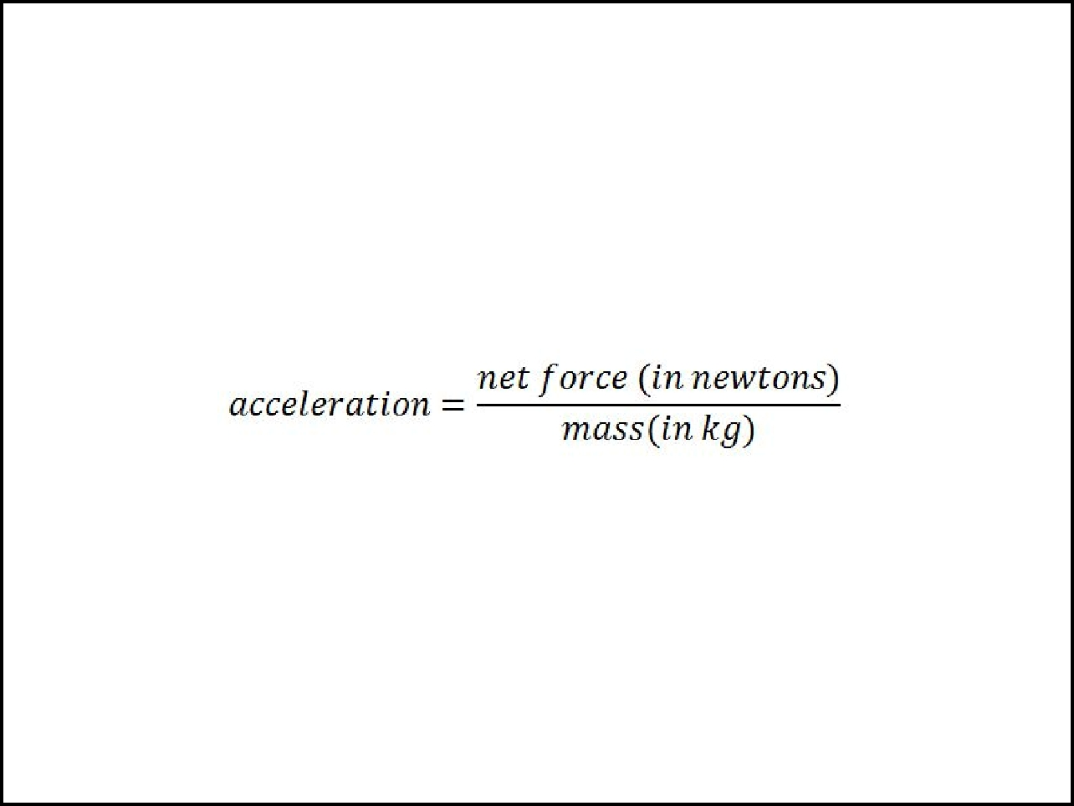

Newton's Second Law of Motion

the ____________________ of an object is in the same direction as the net force on the object and can be calculated with this equation:

Or simply............ __________
Mass = how much ________ is in an object
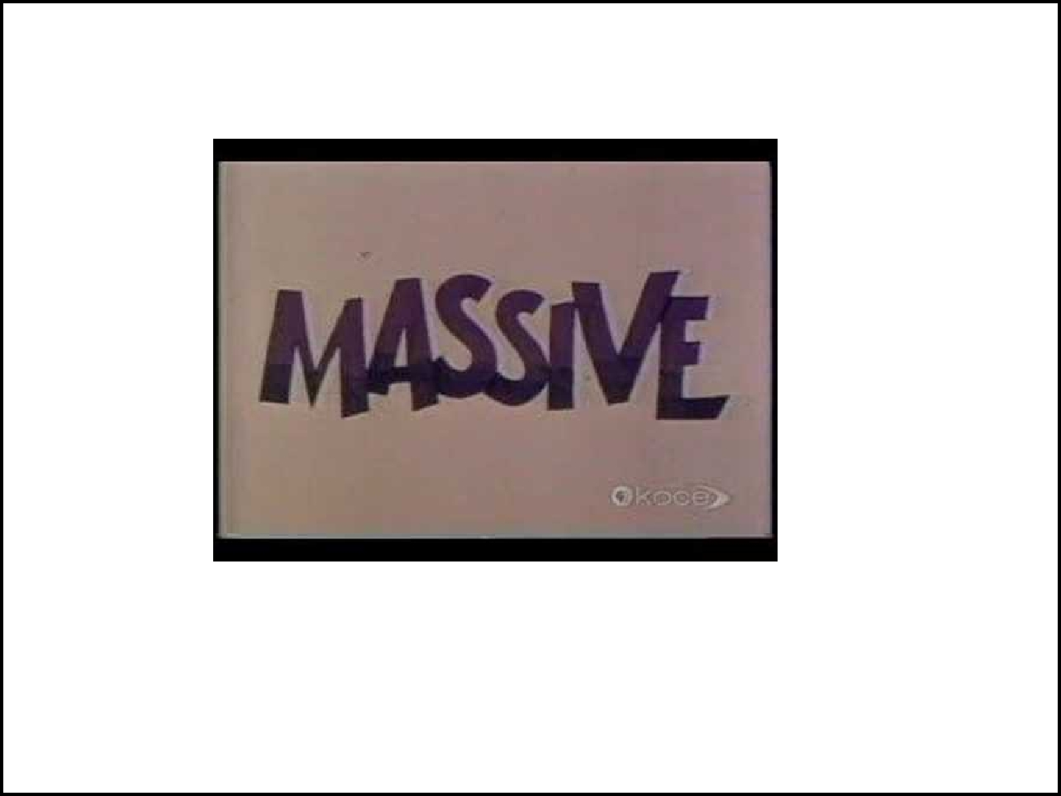
Eureka! V ideo on Mass

More mass = greater _________________ (harder to move or stop)
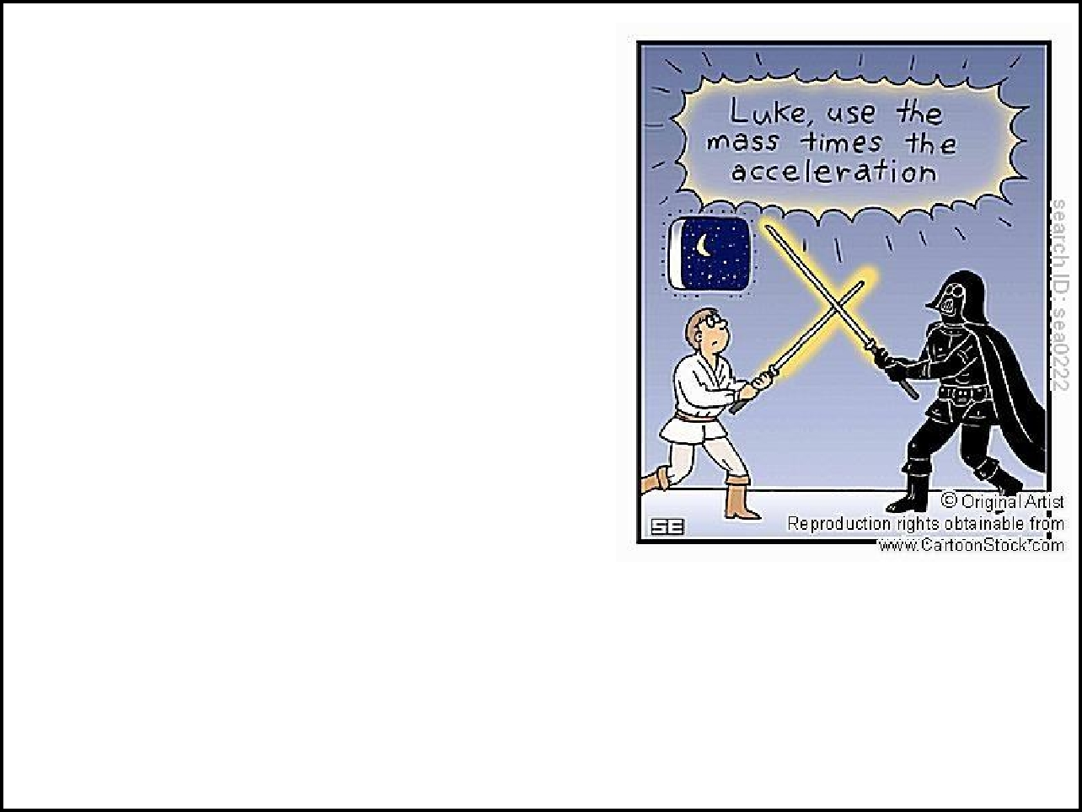

Practice:

1. If you push an object that has a mass of 2 kg, and the net force acting on the object is 6N, what is the object's acceleration?

F = ma or a = f/m

2. If a mass of 5kg is moving at an acceleration of 3 m/s², what is the force?

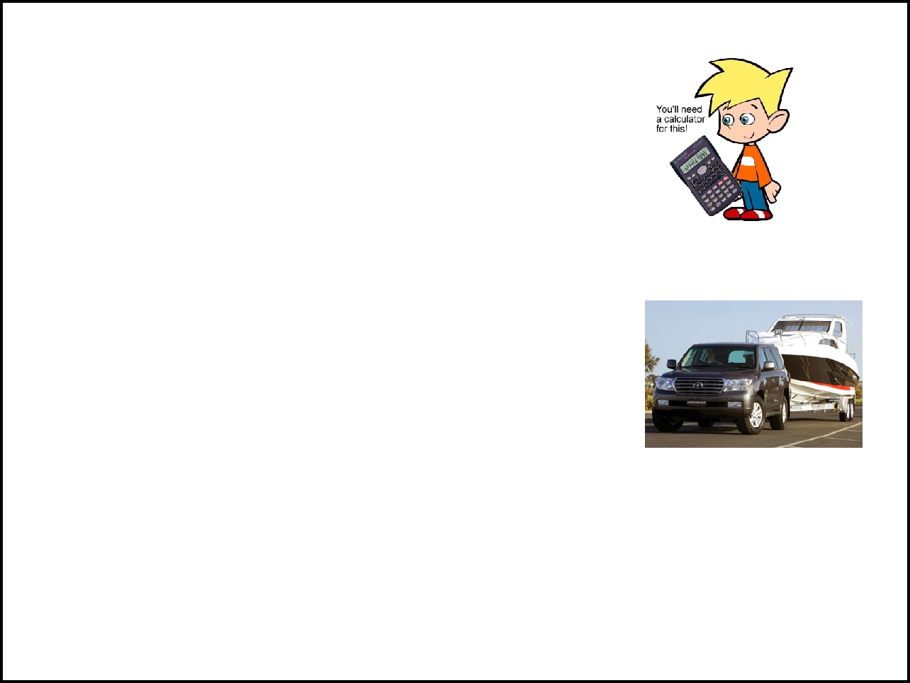
More Practice

- If a helicopter has a mass of 4,500 kg, and the net force on it is 18,000 N, what is the helicopter's acceleration?

- A boat being pulled by a truck has an

acceleration of 2 m/s². What is the mass of the boat if the net force on the car is 3,000N

3. A block is being pushed with a force of 10N and it has a mass of 20kg. What force is acting on the block?
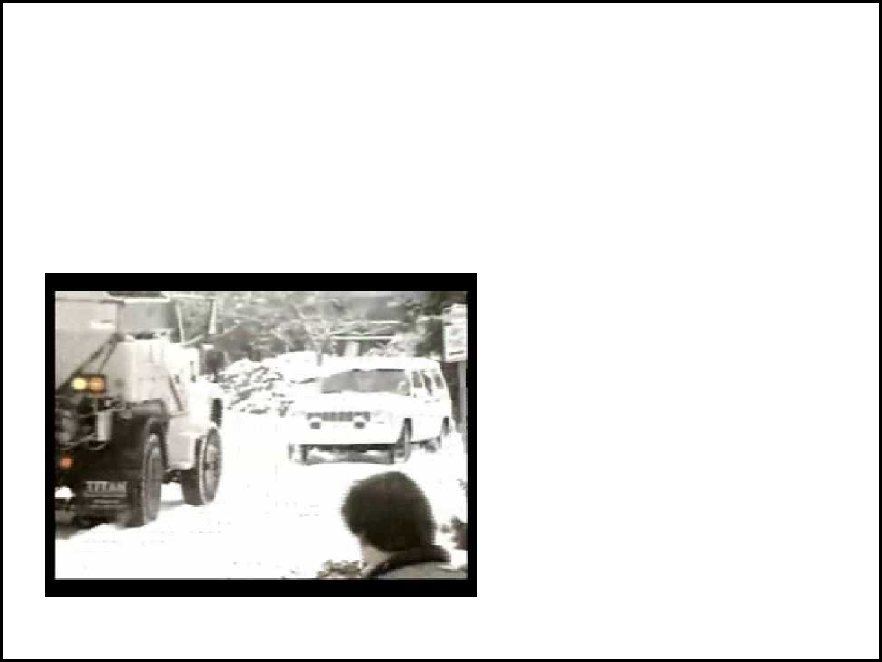
Friction = a force that __________the sliding motion between two objects
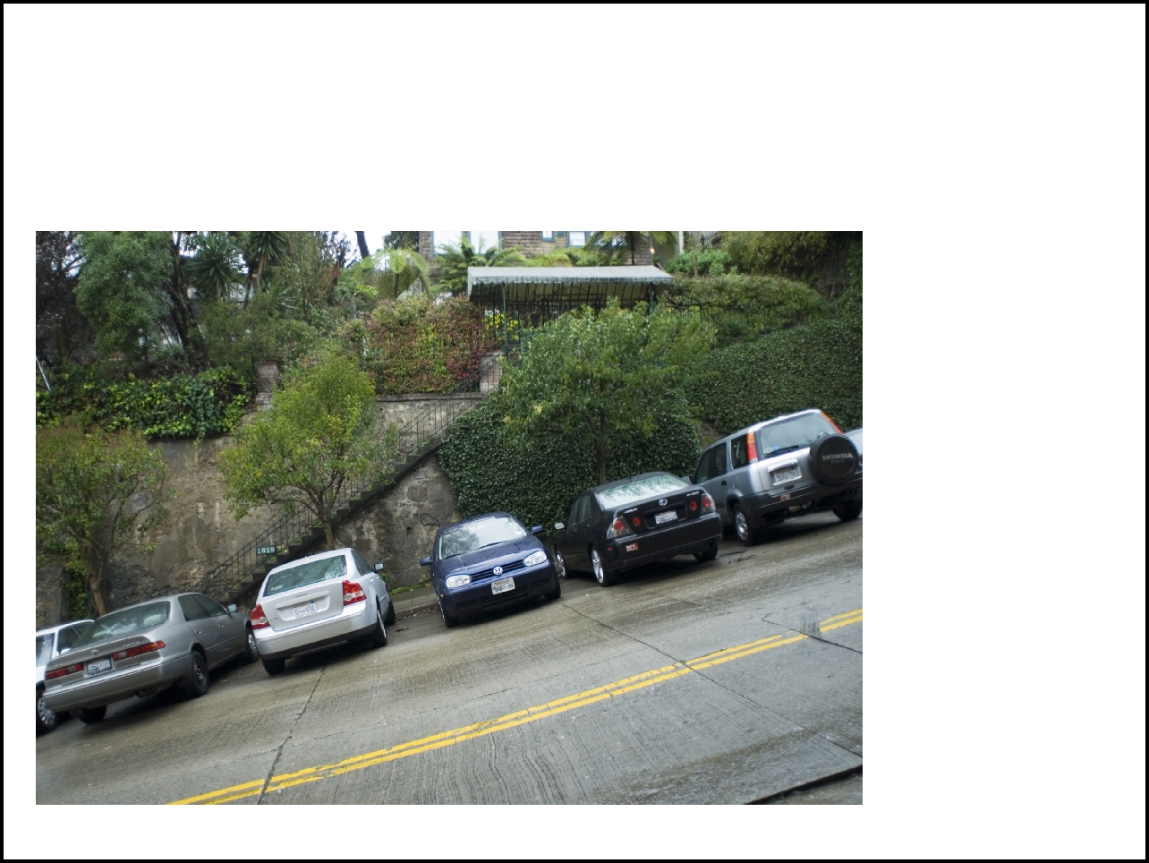
It keeps these cars from sliding down the hill.

images by photoeverywhere.co.uk


The amount of fiction depends on the ________________ and the ____________ pressing the surfaces together.

An icy surface has less friction than a dry surface.

Why does putting sandbags in your trunk help you to not slide on the ice?

_____________ is what prevents two surfaces from sliding past each other.
Ex. You push a large box, but it just won't move

Check Out this link:

http://www.absorblearning.com/media/item.action?quick=y3

____________ is the forces that opposes two surfaces that are already sliding.

Ex. Once you get the box moving, it is easier to slide.

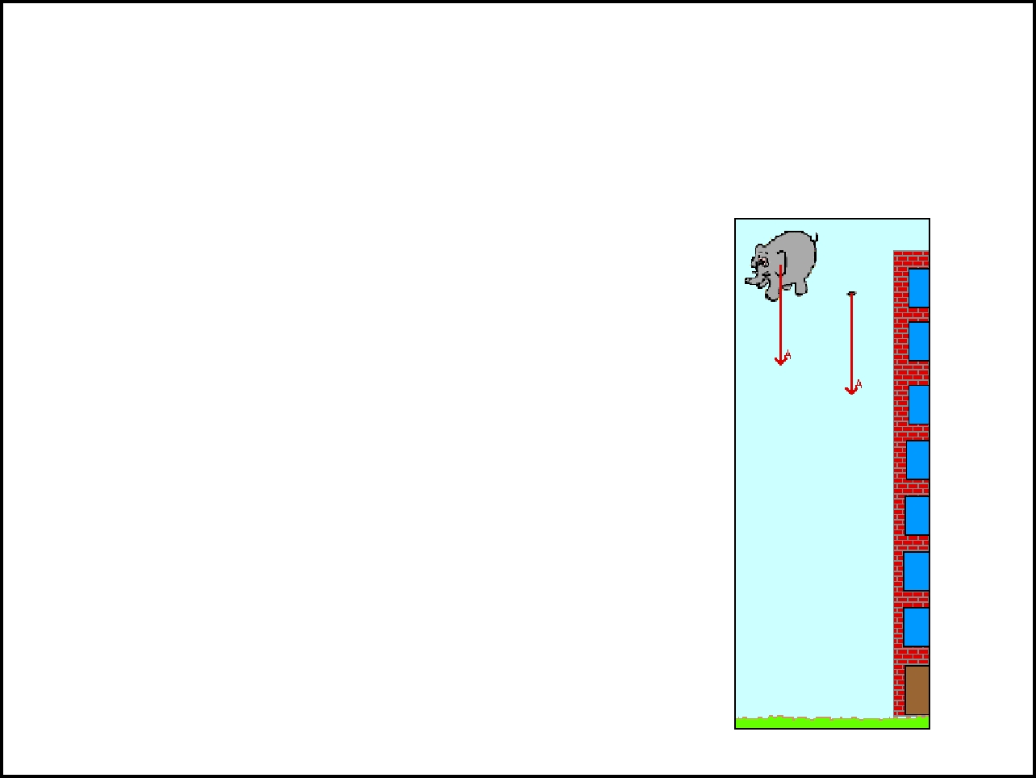
Air Resistance = a friction like force that affects objects that _________________

The feather has more air ____________, so it falls slower than the elephant.

Check out another newton simulation at http://www. visionlearning. com/library/flash_viewer.php? oid=1884
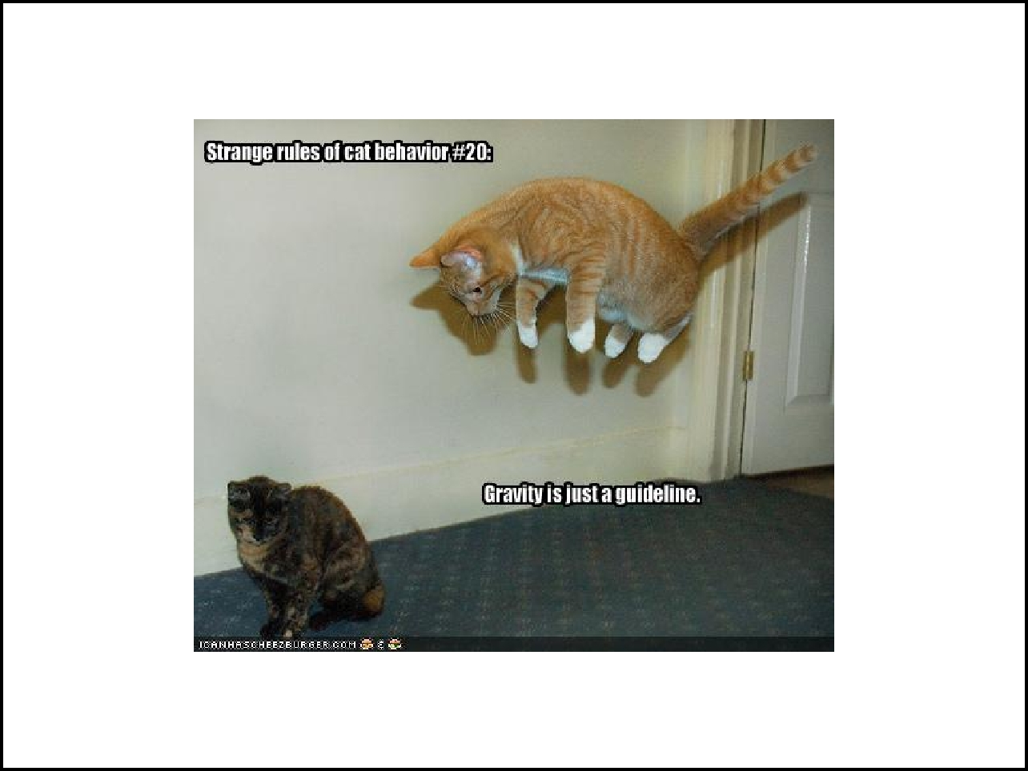
If you jump out of a plane, you might want to use a ____________.
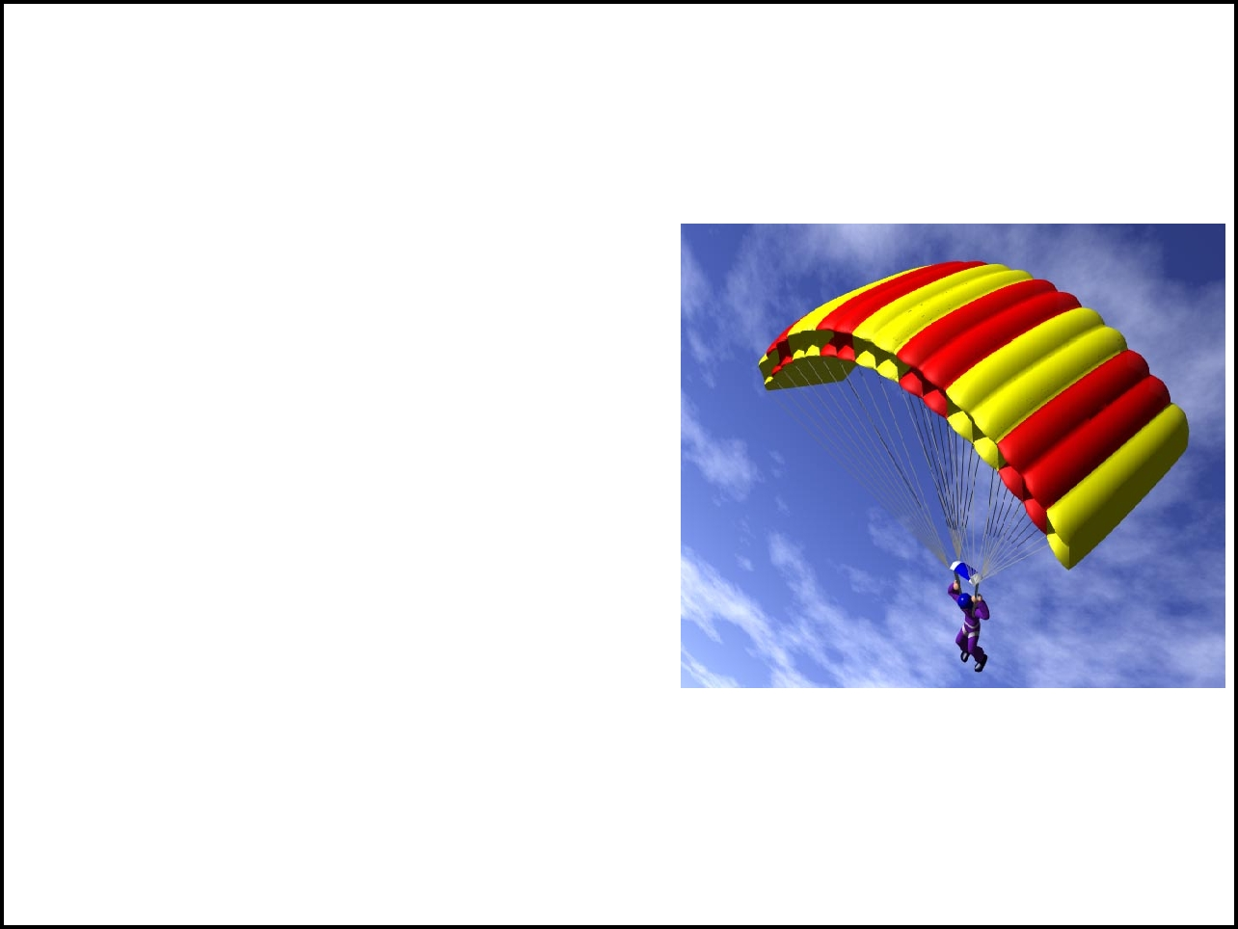
When you first jump out a plane, __________ is the force acting upon you (with some air resistance).

Eventually, the force of the air resistance and gravity is __________ and you no longer accelerate - this is called the ____________________________

See Video

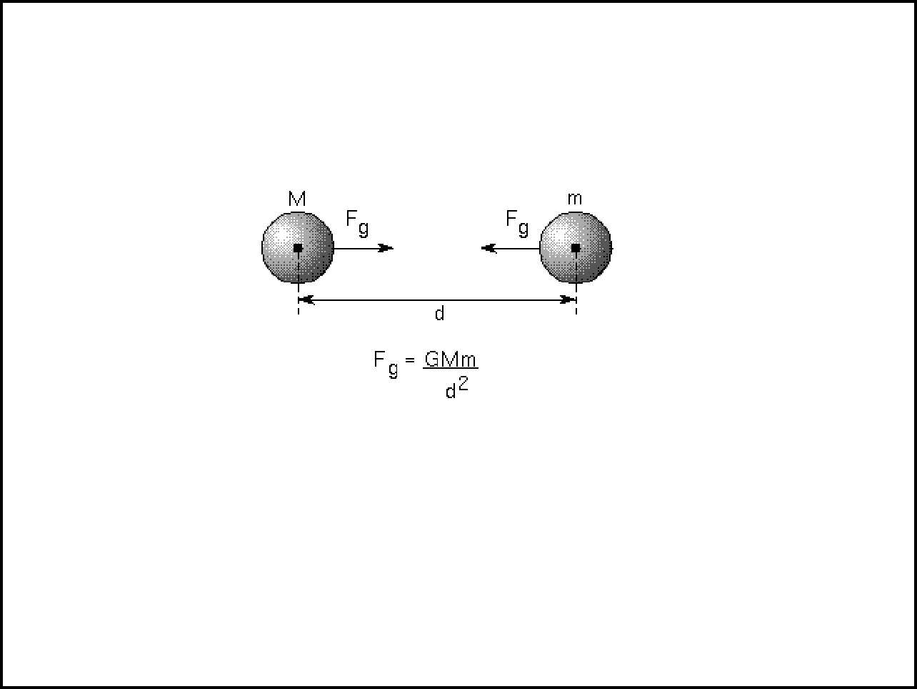
Gravity = the attractive force between two objects; depends on mass and distance

Law of Universal Gravitation.

Fg = Force of Gravity M = mass1
m = mass 2 d = distance

G = a constant

If the objects move farther apart, the force between them will [increase / decrease / stay same]

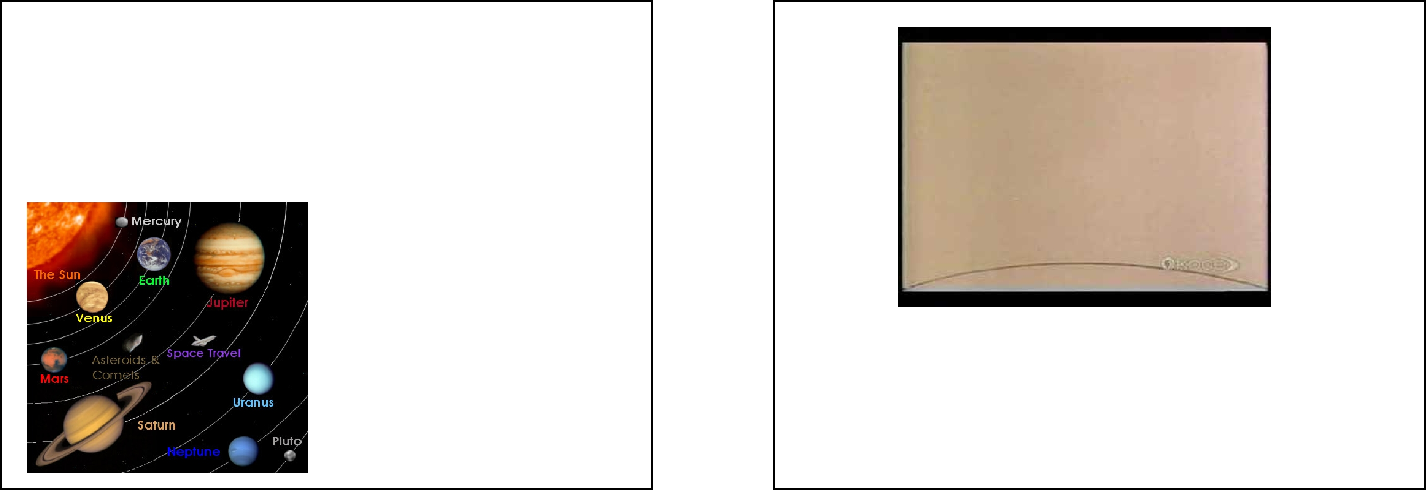
Neptune was discovered in _____ because scientists noticed that Uranus was moving different than expected. Why? Because there was an unseen __________ behind it adding its own force to Uranus.

These forces explain why the moon travels around earth and why we have ocean tides.

The rate of acceleration at which every object falls to the earth is __________ m/s²

F(gravity) = mass (kg) x acceleration of gravity (m/s²)
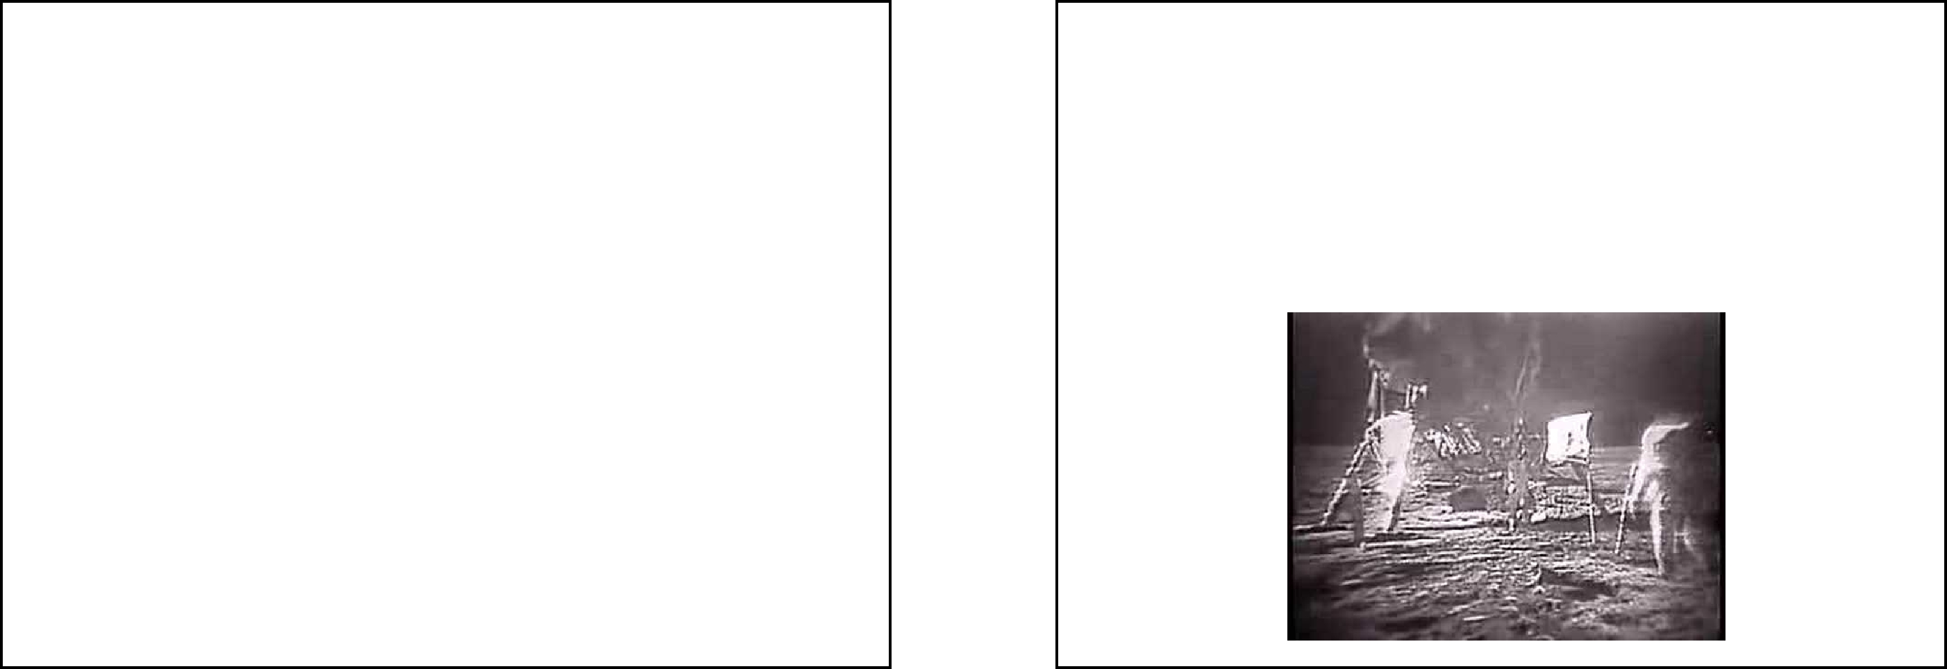

____________ = the gravitational force exerted on an object

____________= the amount of matter in an object

Weight = mass(kg) x 9.8(m/s²⁾

Weight measured in _______

Weight depends on gravity, which can vary depending on the planet. The force of gravity on the moon is ______________

So, you would actually weigh less on the moon than you weigh on earth.

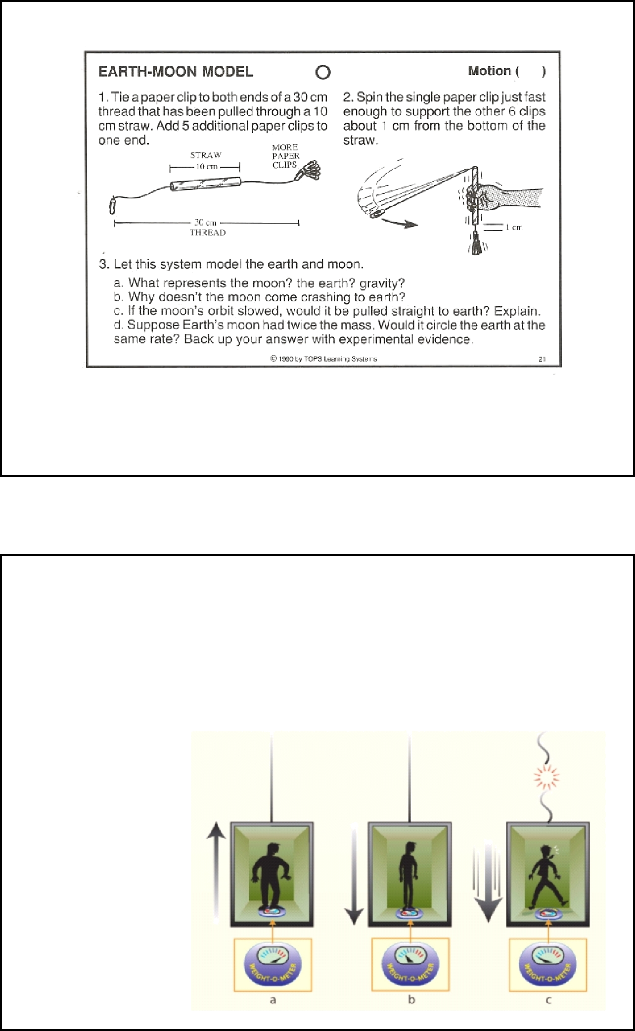

Elevator Physics

When you travel in an elevator, the force acting upon you varies depending on whether you are going up and down. For a very short period, you will be "weightless" as the elevator's ________________ is equal to the acceleration of _________________.

If you stand on a scale while an elevator moves:

As it moves upwards, your weight will _________________

As it goes down, weight _____________

At free fall, weight = ___
Weightlessness & Free Fall
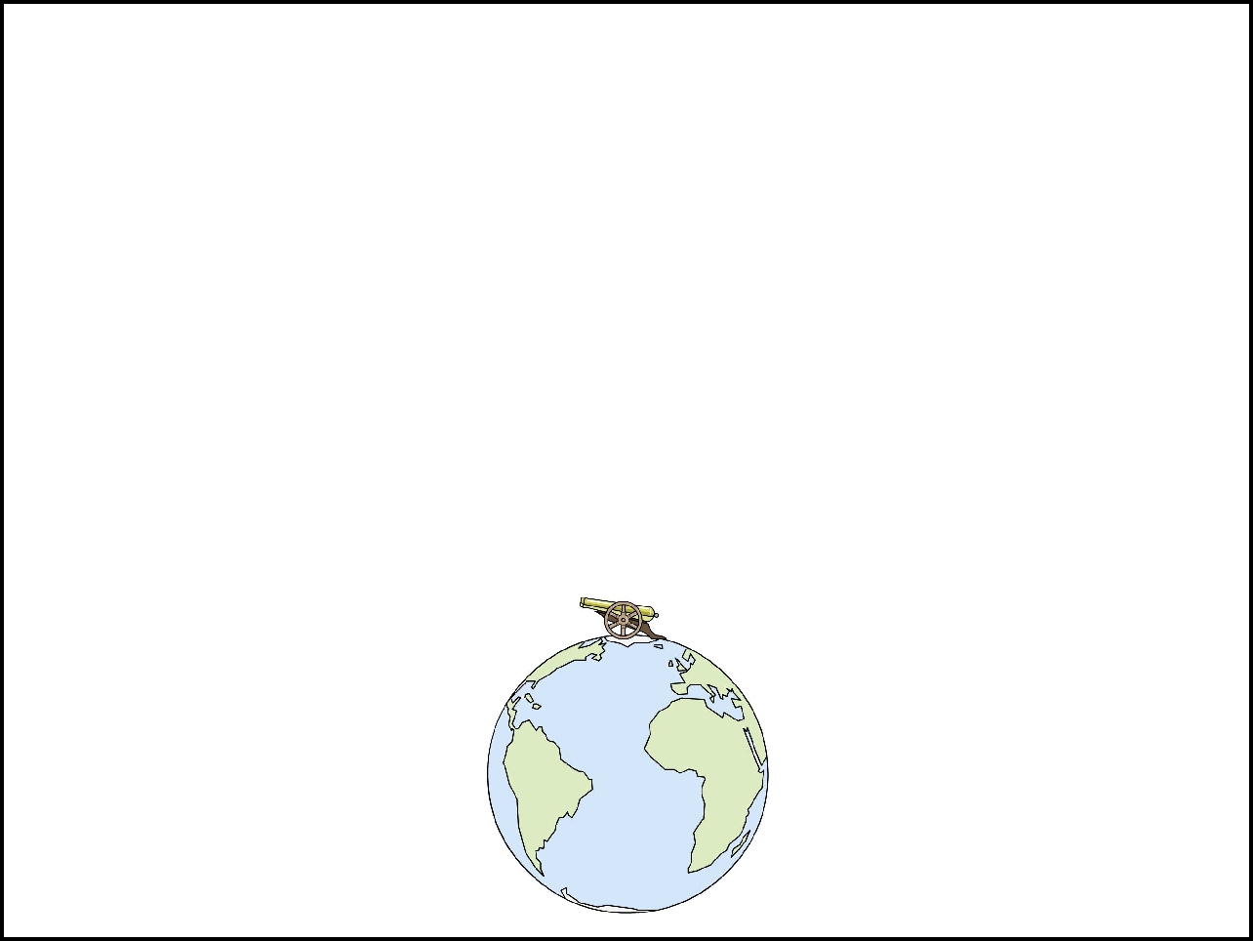

When an object appears to be floating, like the astronauts in space, it is because the force of gravity isn't as strong, so they *feel* _______________. Astronauts still have mass, and in actuality, gravity is still acting upon them, they are just falling *____________________* the earth, not straight down.

Check out this animation of an orbiting cannonball

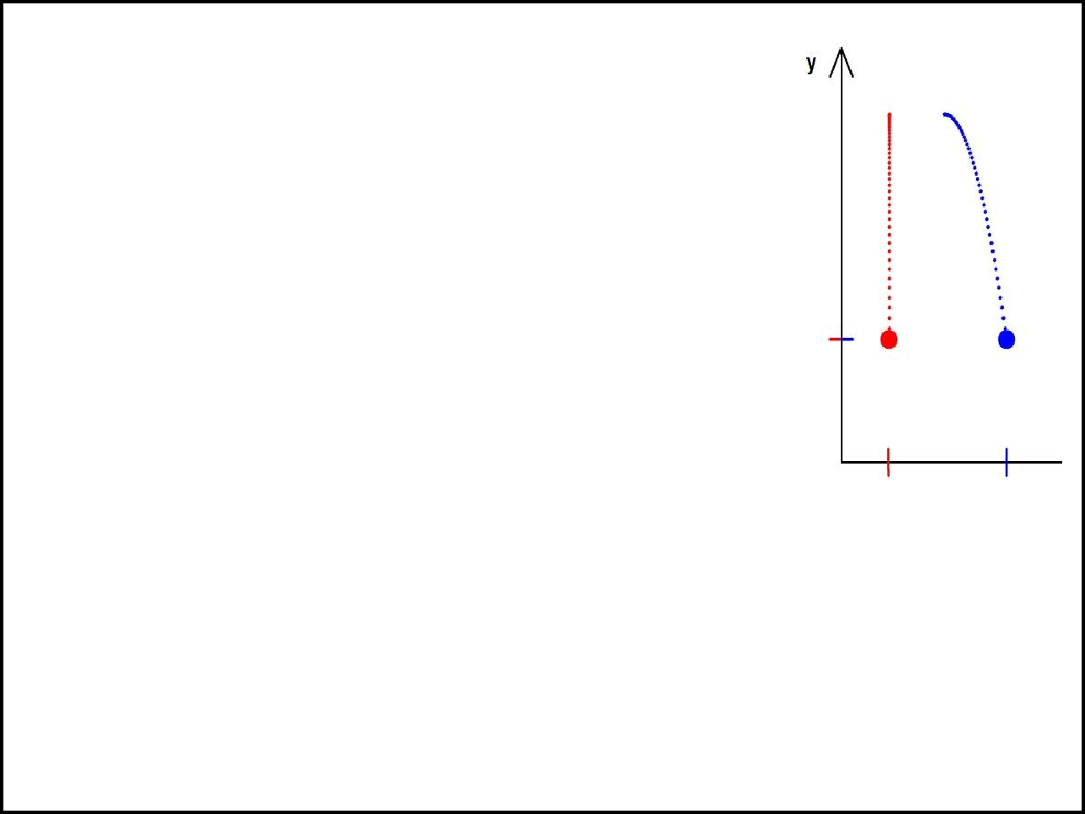
Projectile Motion

Imagine two balls on top of a building. One is dropped and the other is thrown. Which one lands first?

This is a question regarding _____________

motion. The thrown ball has both horizontal and vertical motion, and the dropped ball has only _______________________motion.

To answer the question: check out this animation
Dropping Two Balls Near Earth Surface

Which one lands first? _______________

*You'll be going to the computer lab to study elevators and projectile motion.

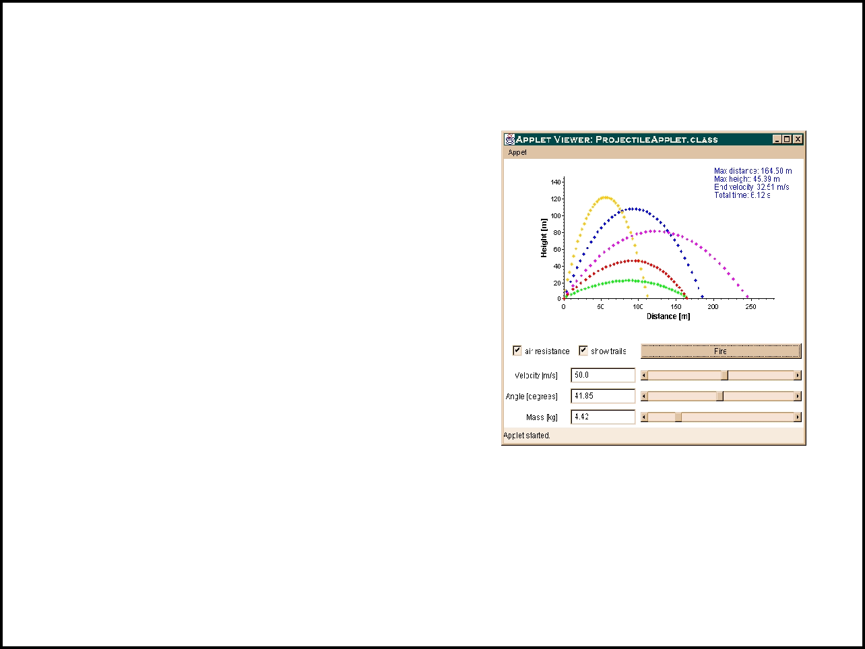
Watch this applet on projectile motion
High Speed Rail Coming to a Town Near You
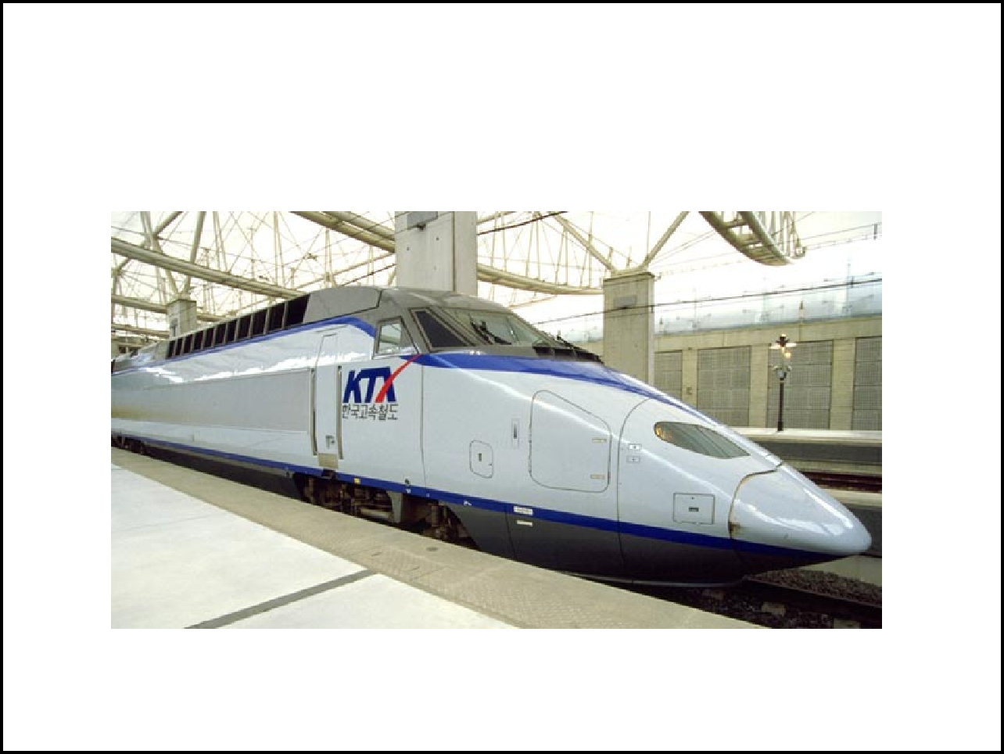

Answer the following with regard to range (use
terms: increase or decrease, or not change)

- Increasing angle will

________ range

- Increasing speed will

_________ range

- Increasing the mass will

_________
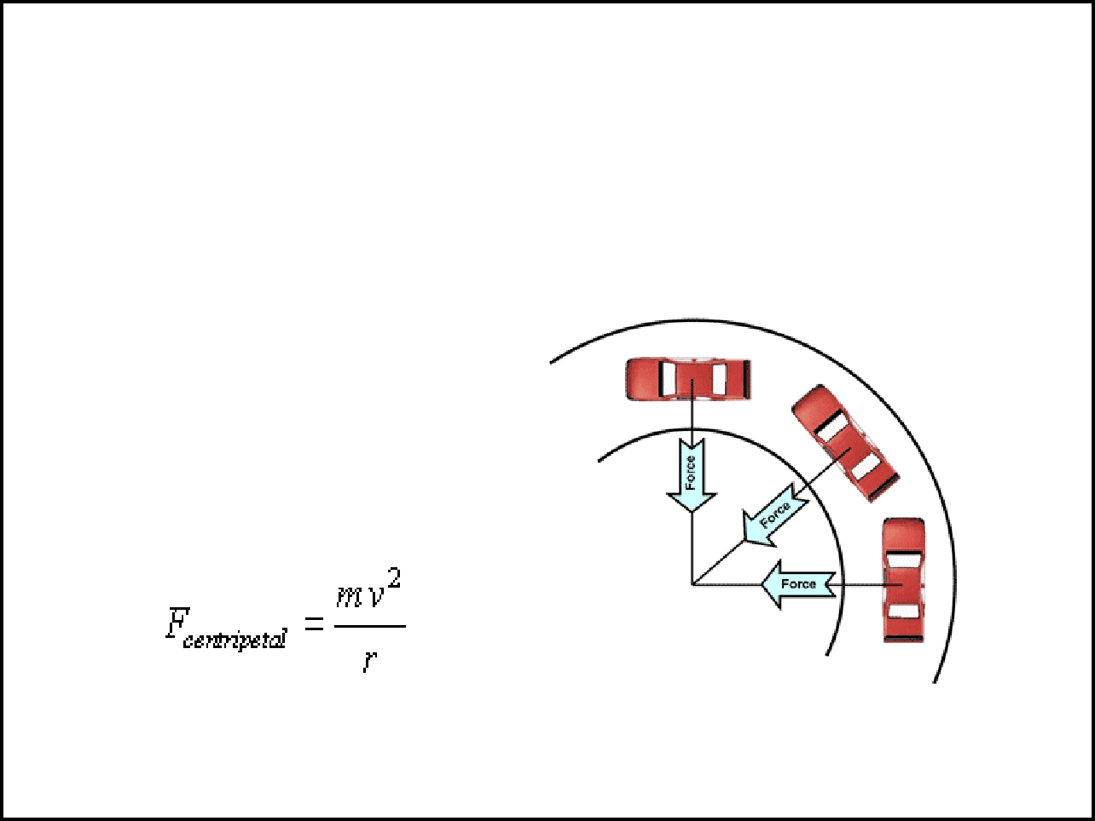

http://galileo.phys.virginia. edu/classes/109N/more_stuff/App lets/ProjectileMotion/jarapplet. html
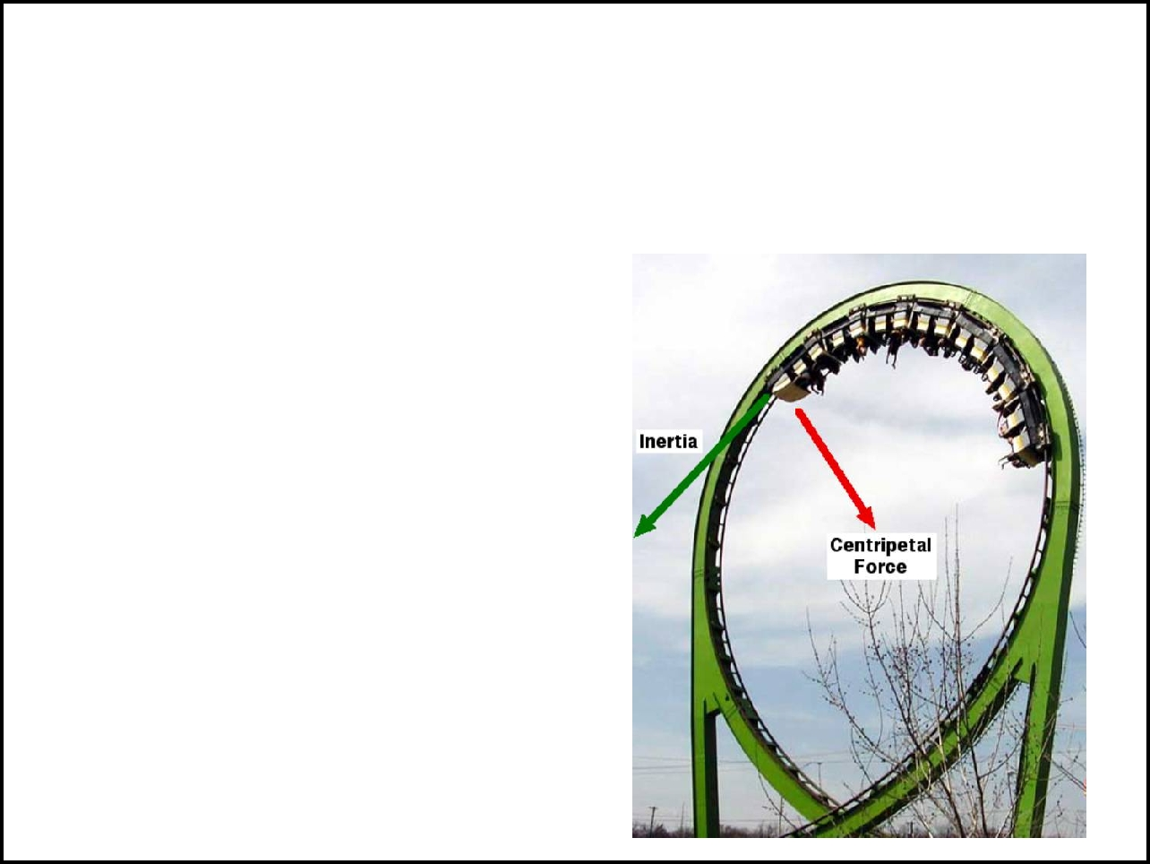

CENTRIPETAL FORCE = acceleration

toward the center of a _____________; as an object goes around a curve, it ________________, producing a force

The force depends on mass, velocity and the __________ of the circle.

When you are in a car turning, you feel like you're being pushed toward the outside of the turn. People refer to this as the centrifugal force, a term that is a unfortunate because there isn't any force pushing you outward. Centrifugal force is what physicists call a ______________ or a fictitious force, because it doesn't really exist.

Examples of ______________

___________________ goes around a loop but the car (and people) don't fall

You can spin a __________ full of water around your head without losing the water.

