Build your own spirometer!
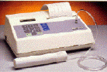

a professional spirometer
Spirometers are used to measure the amount of air that fits in your lungs and how much air you normally inhale and exhale. This is very useful in learning about our bodies and can help doctors determine if we are sick. You can read more about this in How We Find Out.
To build a spirometer, you will need the following things:
1- 3 liter soda bottle (empty) with cap
1- 2 foot piece of plastic tubing
1- measuring cup with units in milli-liters
1- a bucket or pan that can hold more than 3 liters of water
1- marker
To build the spirometer use the following procedure:
1. Add half a liter of water (500 milli-liters) to the soda bottle using the measuring cup and mark a line with the marker at the top of the water level. Repeat this until the bottle is full. When the bottle is full, put the cap on the bottle.
- This is done to put measuring lines on the bottle.
2. Add sufficient water to the bucket or pan to submerge the soda bottle.
3. Invert the soda bottle and submerge it in the bucket, and remove the cap under the water.
- We open the bottle underwater to prevent any unwanted air from entering the bottle.
4. Place one end of the tubing into the soda bottle in the water, and leave the other end outside of the water.
- This is the tubing we will use to blow into, in order to determine lung capacity.
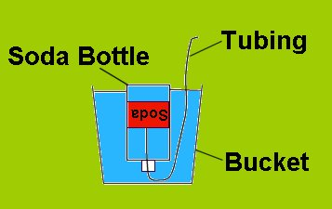  a simple spirometer | Remember to place the bottle in the water upside down before removing the cap.  Don't forget to insert one end of the hose in the bottle after you open the cap underwater  Before you exhale into the tubing, your spirometer should resemble this picture.

To use the spirometer follow this procedure:
1. While a partner holds the bottle to keep it from flipping over, inhale normally, then exhale the air normally into the tubing connected to the spirometer. Be sure not to blow out all the "extra" air in your lungs. Make a good estimate of the amount of air you exhaled, remembering that each line on the bottle represents a half liter, starting from the top down.
- Write this number down, it is your "tidal volume." The tidal volume is the amount of air that you normally breathe in and out.
2. Refill the bottle with water and reinsert the tubing. While your partner holds the bottle, take a few normal breaths to help get a good reading on this next step, and then inhale as much air as you can and exhale this air into the end of the tubing outside of the water. Make a good estimate of the amount of air you exhaled by looking at the lines on the soda bottle.
- Write this number down, it is your "inspiratory reserve." The inspiratory reserve is the amount of air that your lungs can hold in.
3. Refill the bottle with water and reinsert the tubing. While your partner holds the bottle, take a few normal breaths to get yourself back to a normal breath, and then exhale as much air as you can into the end of the tubing outside of the water. Make a good estimate of the amount of air you exhaled by looking at the lines on the soda bottle.
- Write this number down, it is your "expiratory reserve." The expiratory reserve is the amount of air that your lungs can blow out after a normal breath..
How much air can my lungs hold?
- If the "inspiratory reserve" and the "expiratory reserve" and the "tidal volume" are added together, then you get the "vital capacity," or the functional capacity of the lungs. The vital capacity is the greatest change in volume that can occur in the lungs. This is not the total volume of air that fits in the lungs, but it is a good approximation.
- Inspiratory Reserve + Expiratory Reserve + Tidal Volume = Vital Capacity

